APPENDIX FIVE
More on Chord Scales

Using Triads to play 7th chords
We can use the triads shown in Appendix Four to play 7th chords. Simply leave out the root note of the 7th chord and build the triad off the 3rd.
- e.g. C Major 7th chord = C E G B.
Building a chord off the 3rd = E Minor. i.e. The notes E G B
So, if we play an E minor triad it will have the sound of a C Maj7 chord with no root note. This can be particularly effective if we are playing with a bass player, who more than likely will be playing the C root note.
Some other examples;
- Cm7, we play an Eb Major triad
- C7, we play an E dim.triad
- Cm7b5, we play an Eb minor triad
This means we can also apply these hybrid 7th chords to create chord scales;
Playing an E minor triad for C Major 7th, then running it through C Ionian
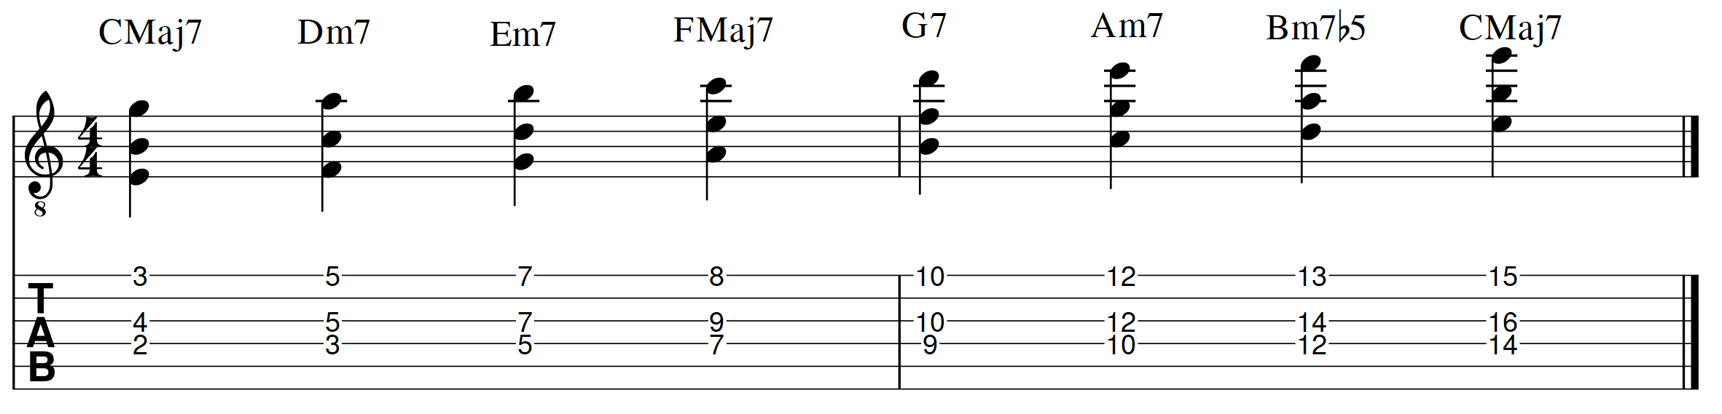
Playing an E dim.triad for C7, then running it through C Mixolydian
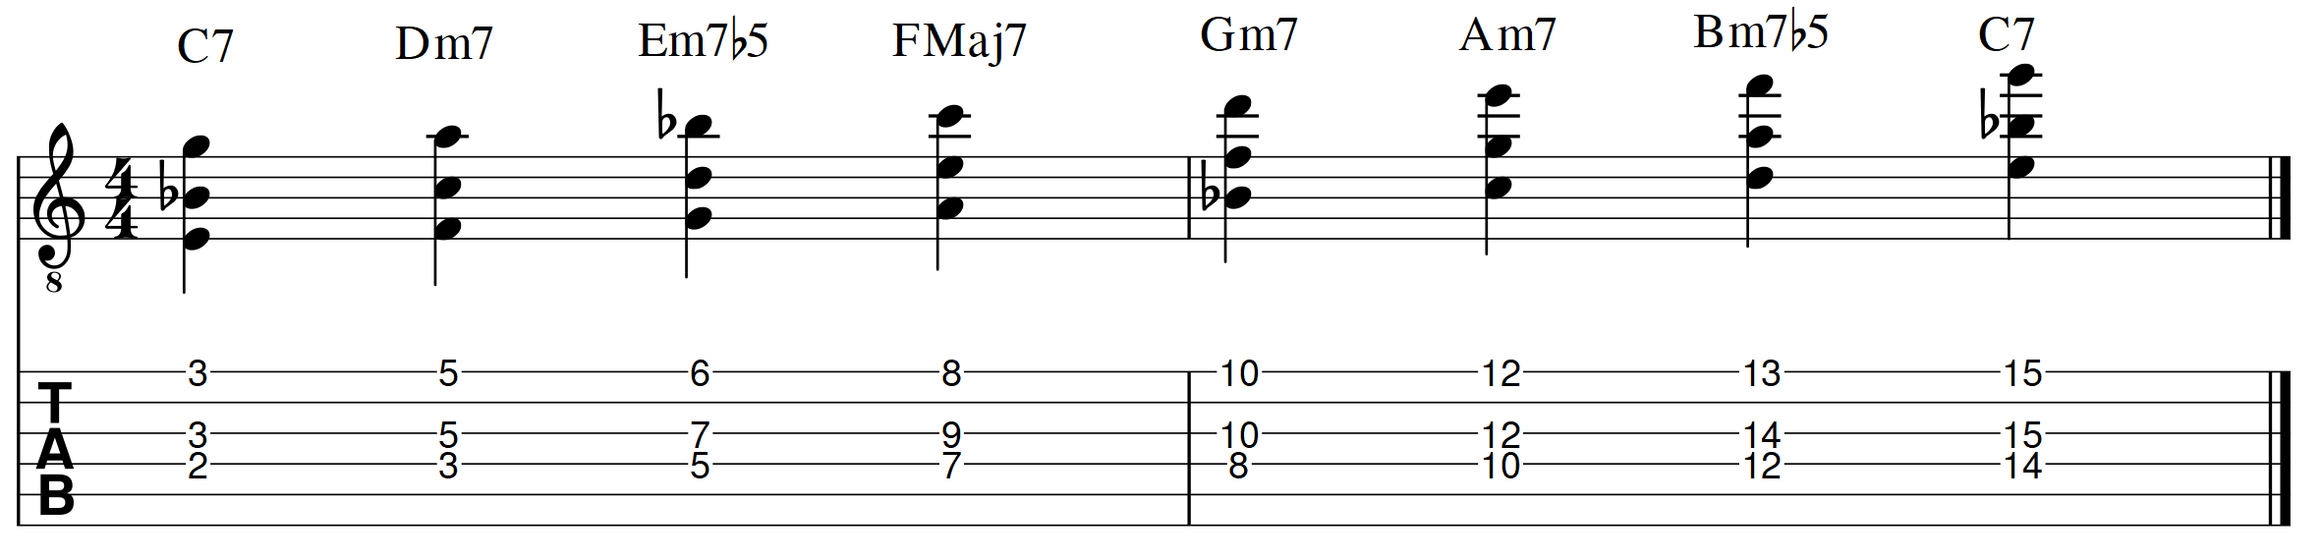
Playing an Eb Major Triad for Cm7, then running it through C Dorian
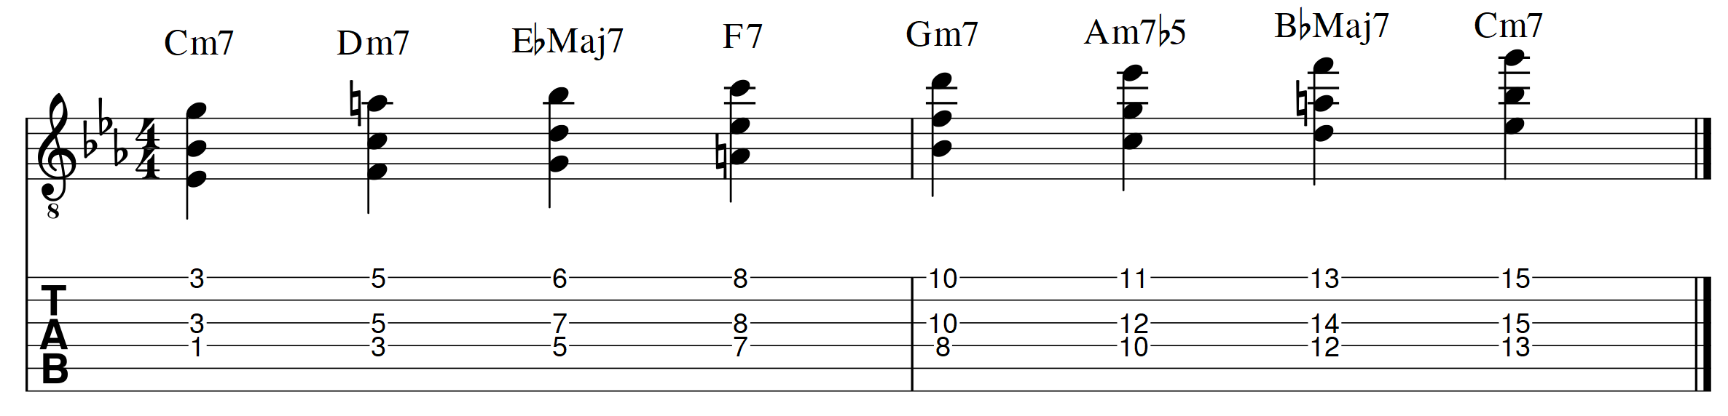
Try these for yourself and experiment. Any key, any mode, create 7th chords by playing triads built off the 3rd of the 7th chord. Then, run the shape through a mode.
Playing an F# Minor Triad for D Major 7th, then running it through D Lydian
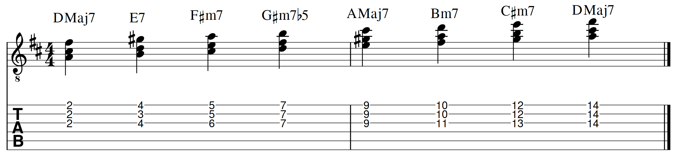
Playing a G Major Chord for Em7, then running it through E Natural Minor
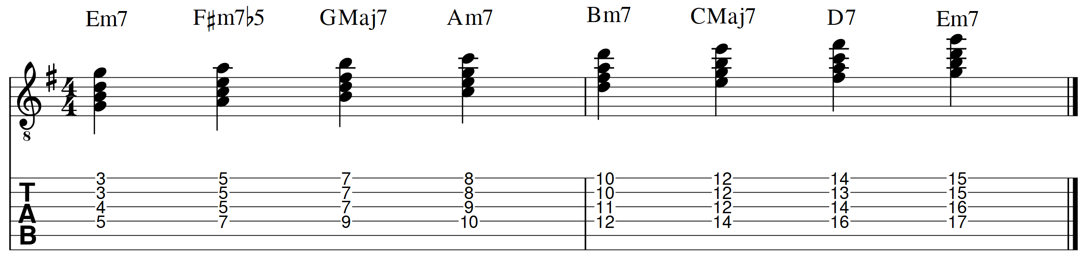

Running Other 7th Chords Through Chord Scales
Our normal 4 note 7th chord voicings can also be used in chord scales. Try the following examples;
G Major 7th Chord ascending through G Ionian
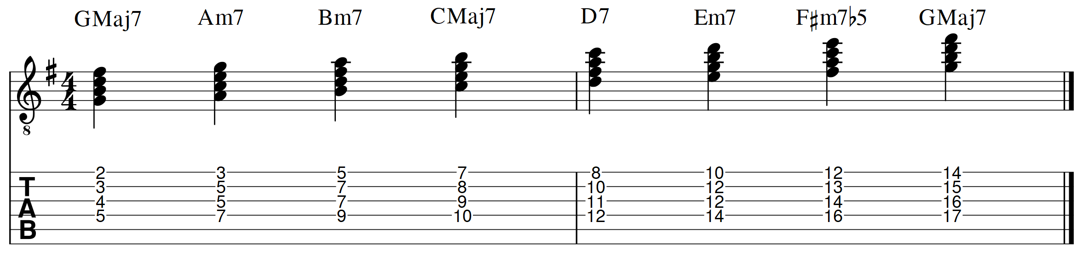
C Major 7th Chord ascending through C Lydian
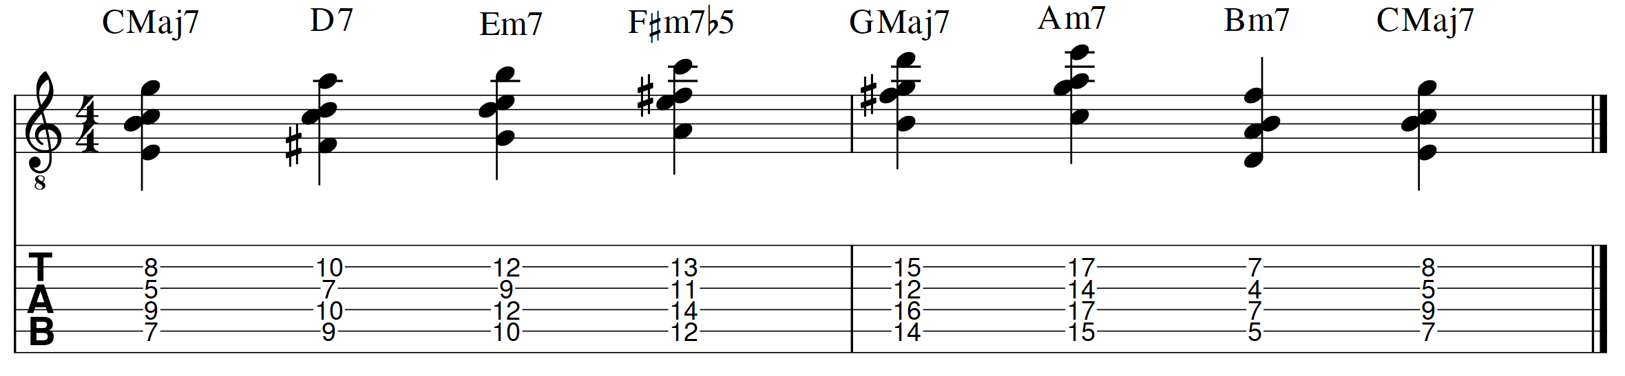F# Minor 7th Chord ascending through F# Dorian
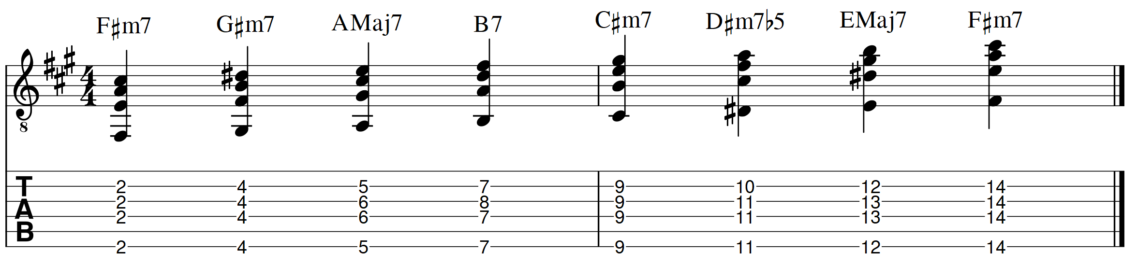Do this with any 7th chord you know – run them through a scale. Major 7th chords can be run through the Ionian and Lydian scales. Dominant 7th chords will work with the Mixolydian scale. Minor 7th chords can be run through the Dorian, Phrygian or Aeolian scales.
Running Other Chords through Chord Scales
Try taking any chord you know and running it through a chord scale. Some chords work better than others, but they are a great way of discovering new voicings. Try the following examples;
G Major 6th Chord ascending through G Ionian
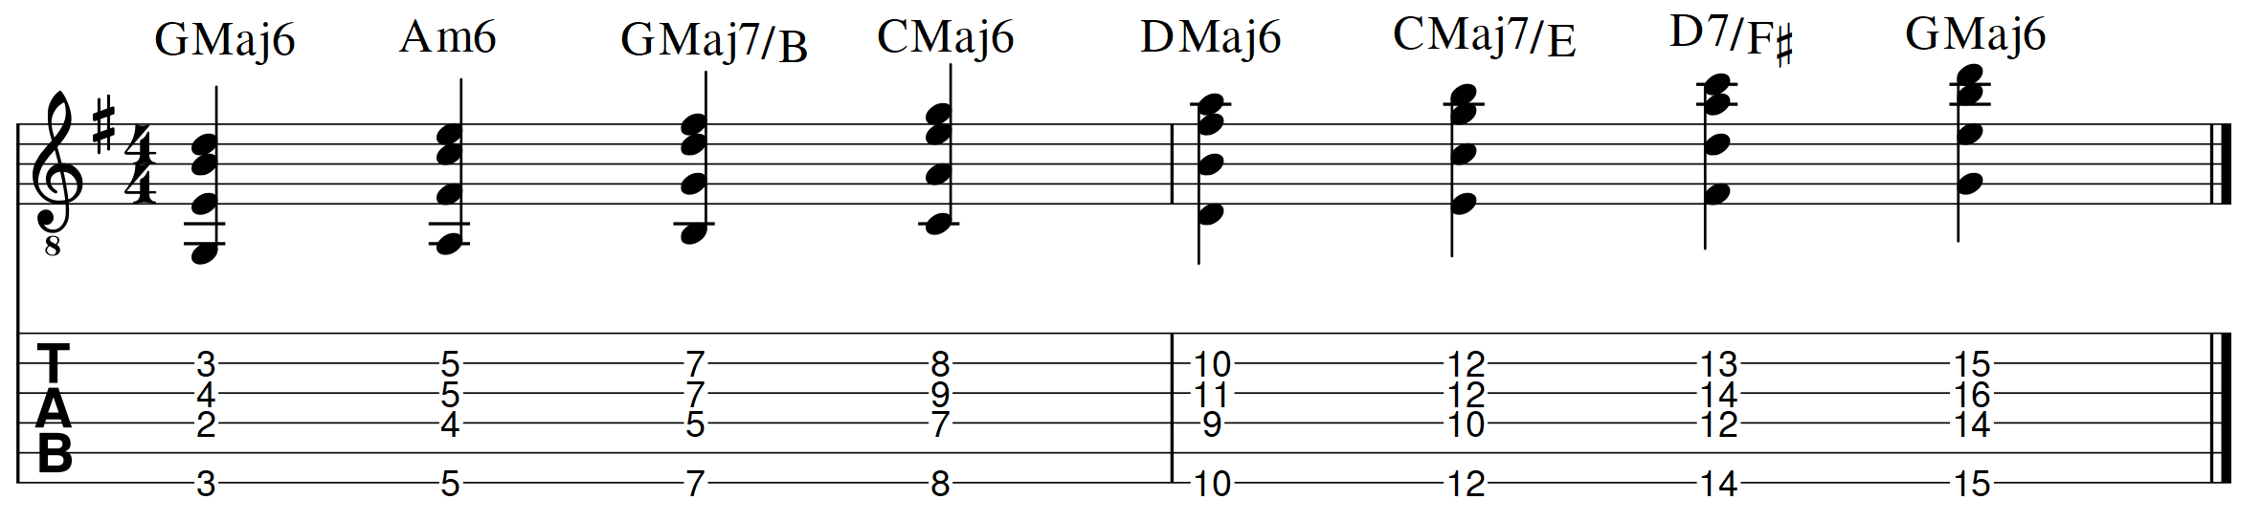F13 ascending through F Mixolydian
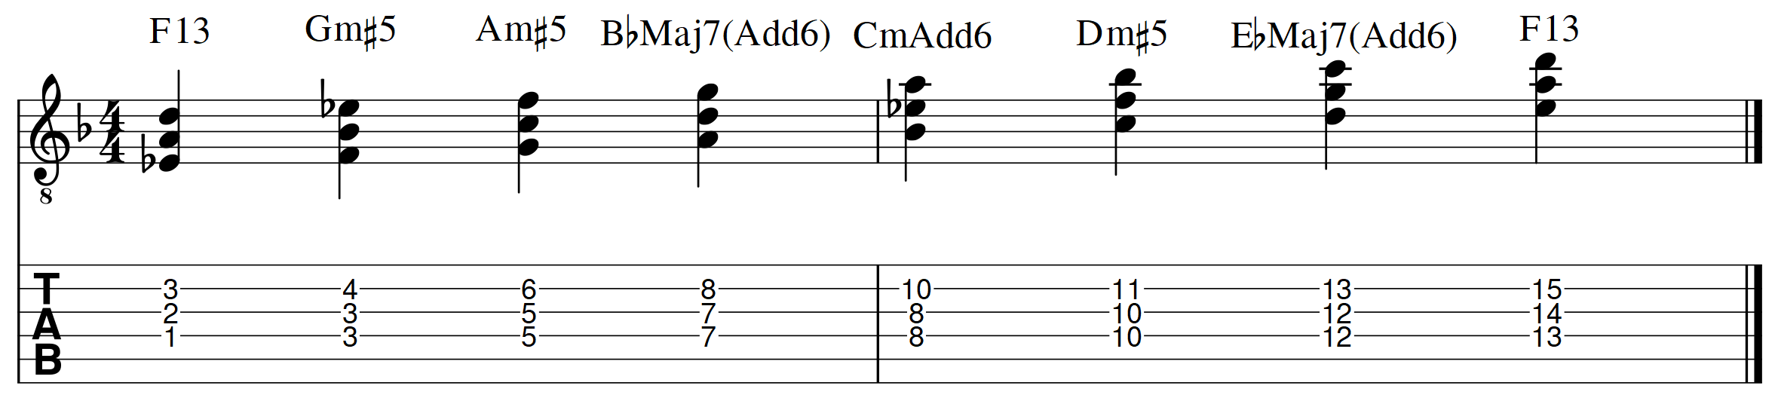
In the example above all the chords could be viewed as F7 type of chords. In styles like modal jazz, swing, bop and fusion they could all be played as F7-type extensions.
Chords in Modal Jazz
The last example shown on the previous page, running F13 through F Mixolydian, is similar to the way chords and harmony are approached during a Modal Jazz piece. On the ground-breaking and influential 1959 Modal Jazz album “Kind of Blue”, by Miles Davis, the great pianist Bill Evans plays a wide range of chord voicings and substitutions, based on the Major Scale modes. The concept is;
Chord Scale New Chords

E.g. The chord is Dm7, from the chord a scale is chosen (e.g. D Dorian), then from the scale new chords are built (e.g. Dm11, A sus4, G9, F Major7b5, etc.).

Of course, this approach to harmony is very dependent on the style of music we are playing. If a rock gig requires a D Major chord and we substitute it with Am7sus4 and G Major 9, there is every chance someone will want to throw something at us! This stuff is all about context and playing what suits the style. It generally works best in styles such as Modal Jazz, some types of Swing, Bop, Fusion, some types of Funk, plus other World Music styles such as Samba, Salsa and Afro-Cuban.

