APPENDIX FOUR
Chord Scales
Chord scales are when we take a chord shape and run it through a chosen scale. Each note in the chord moves up or down to the next note in the scale.
For example, let’s start with this basic F Major triad and move it through some different scales;
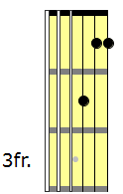
F Major Triad ascending through the F Major Scale
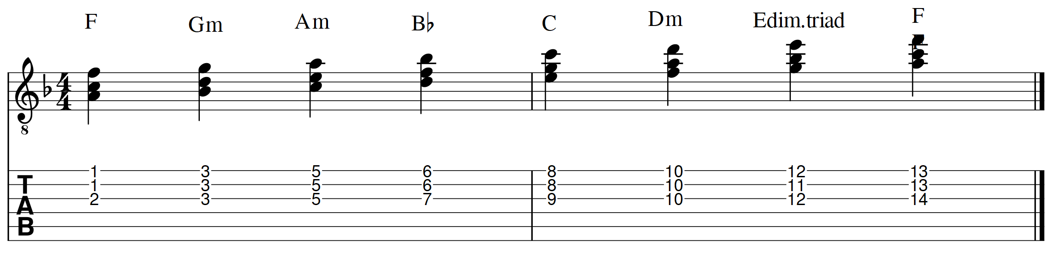
When it comes to the Major Scale Modes, there are 3 modes that have a Major Tonality (Major Scale, Mixolydian and Lydian). Any of these modes/scales can be used when running a Major chord through a chord scale.
F Major Triad ascending through the F Mixolydian Scale
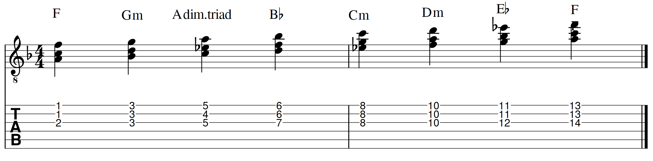F Major Triad ascending through the F Lydian Scale
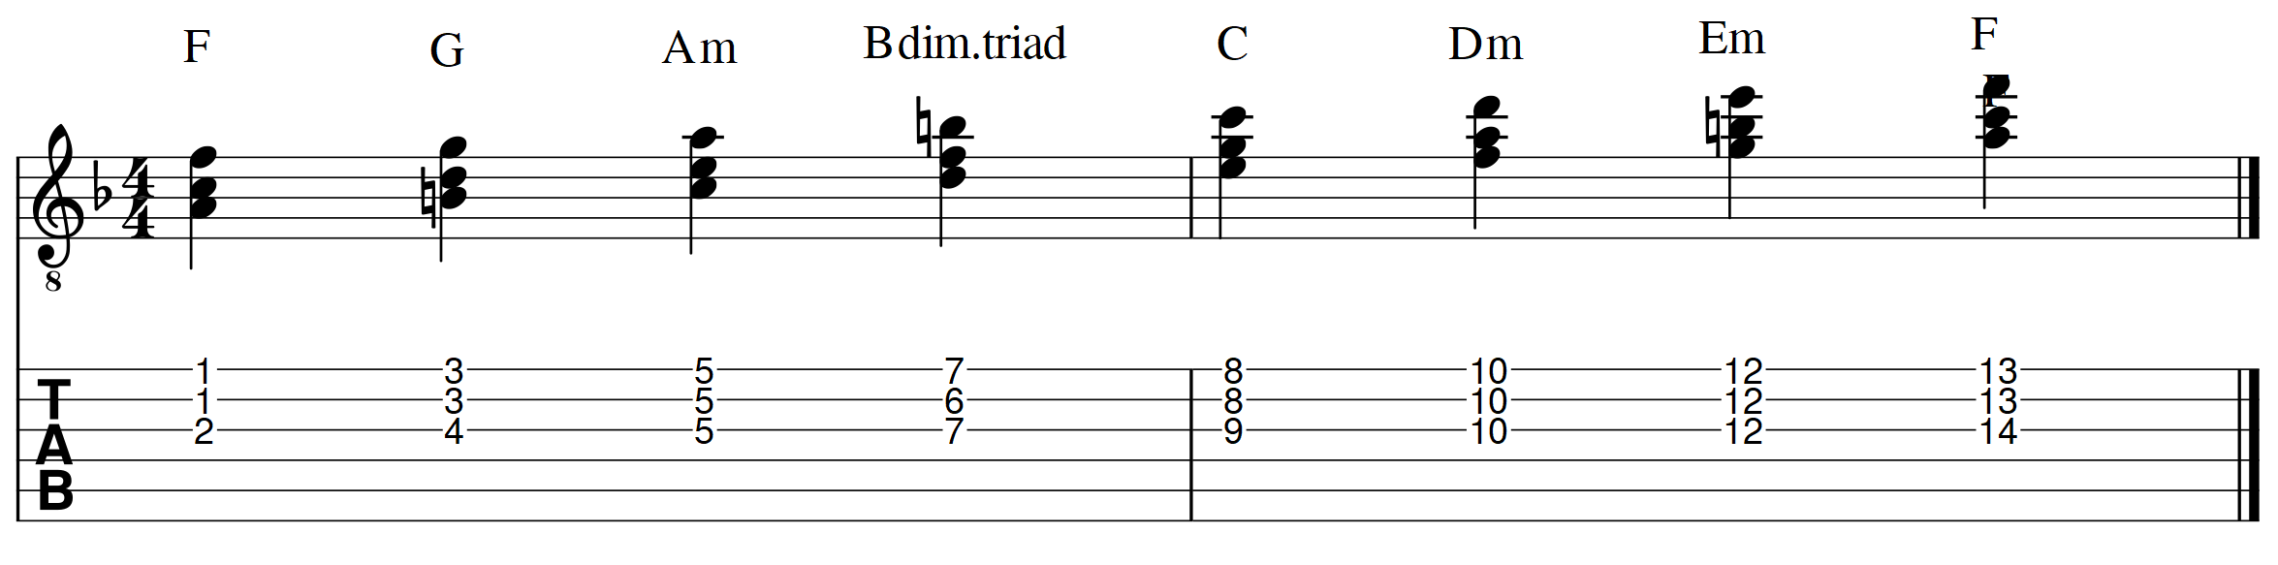
There are 3 Major Scale modes that have a minor tonality (not counting the Locrian mode which has a b5) – Dorian, Phrygian, and Aeolian. Therefore, any of these modes could be used when running a minor chord through a scale. Let’s run this F min. triad through these 3 minor scales/modes;
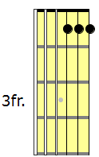
F Minor Triad ascending through the F Dorian Scale
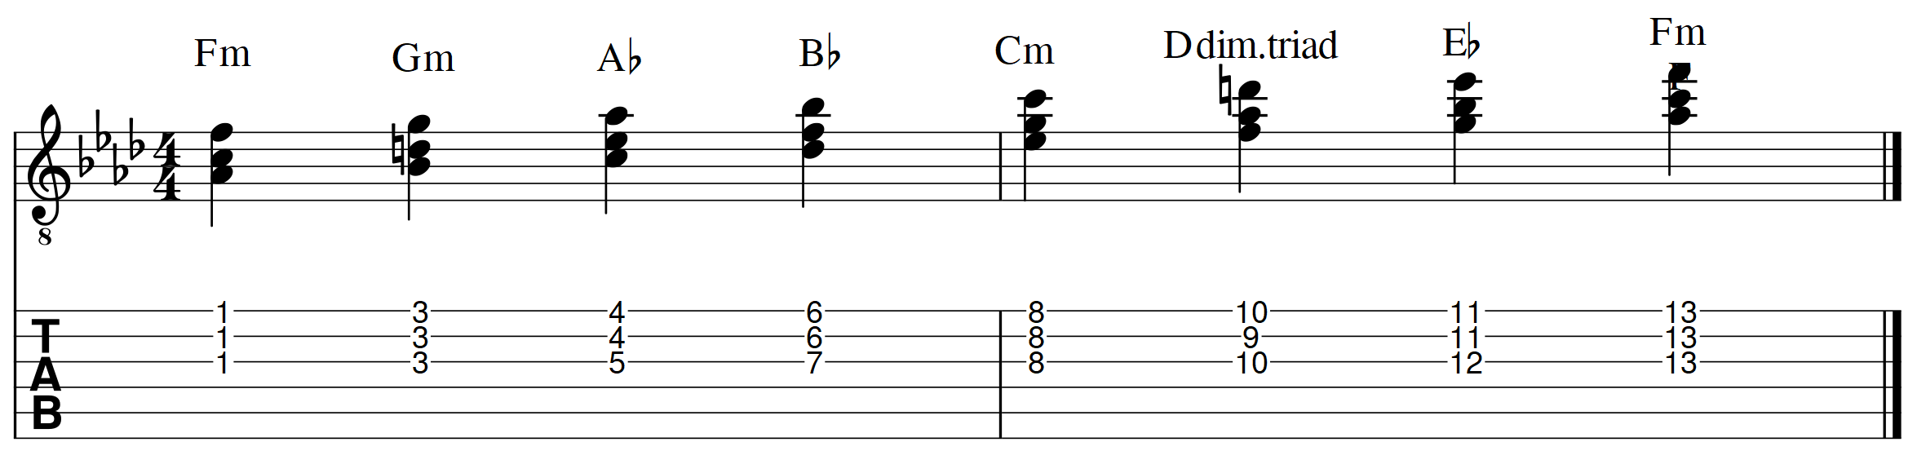
F Minor Triad ascending through the F Phrygian Scale
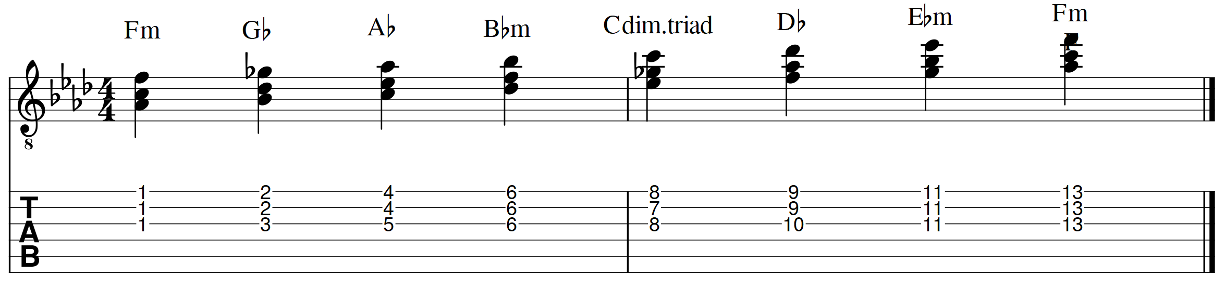
F Minor Triad ascending through the F Aeolian Scale (F Natural Minor)
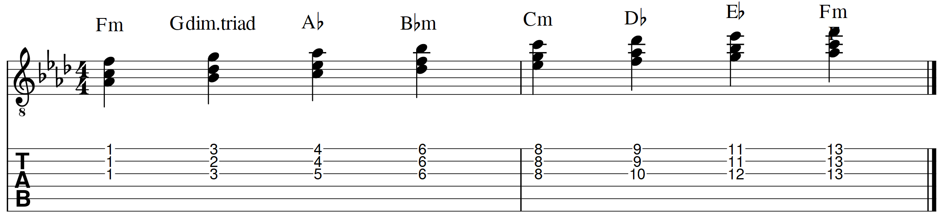
This process can be done with any Major or Minor chord voicing that we know. i.e. For a Major chord, try running it through the Ionian, Mixolydian or Lydian scales. For a Minor chord, try running it through the Dorian, Phrygian or Aeolian scales. There are so many possibilities here it is bordering on the ridiculous, but they are a great way of really developing our chordal and modal knowledge. Chord scales help us to learn and consolidate new chords and voicings.
The following pages show examples of F Major and F Minor chords. Try taking ones you like and running them through chord scales. For an F Major chord, try running it through F Ionian (F Major Scale), F Mixolydian or F Lydian. For an F Minor chord, try running it through F Dorian, F Phrygian or F Aeolian (F Natural Minor).
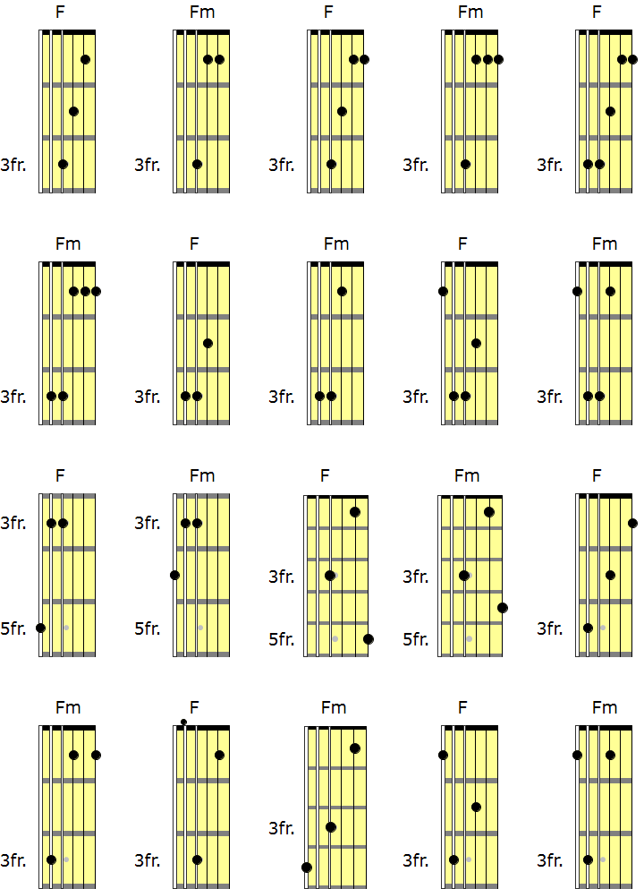

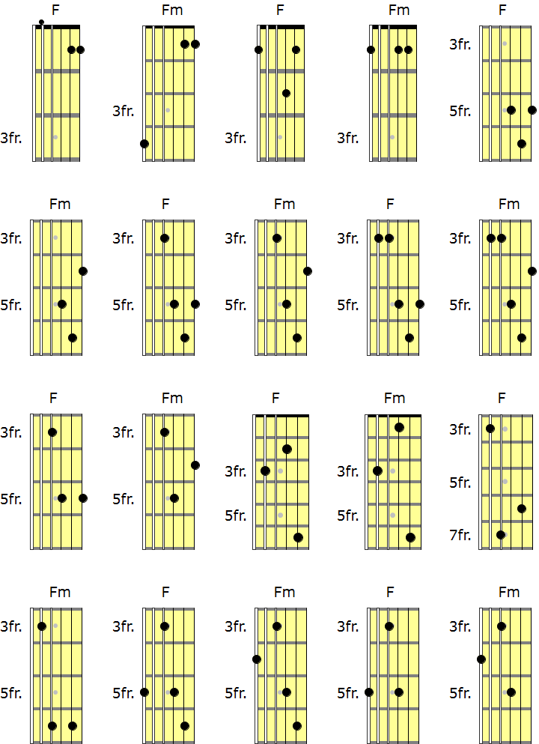

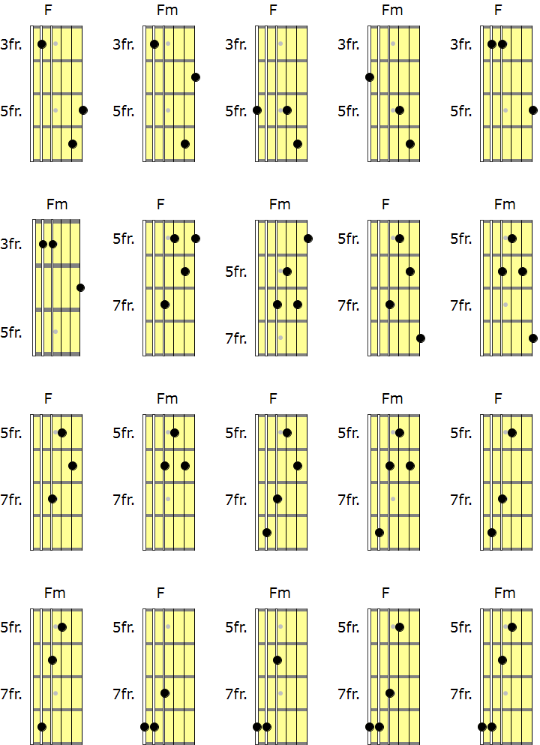

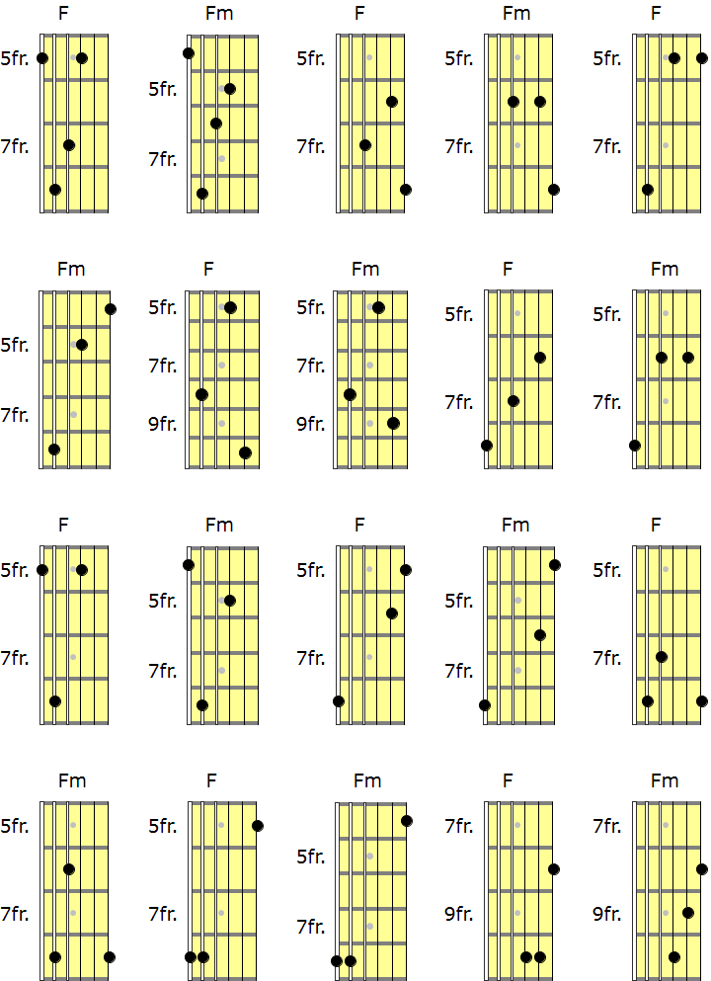

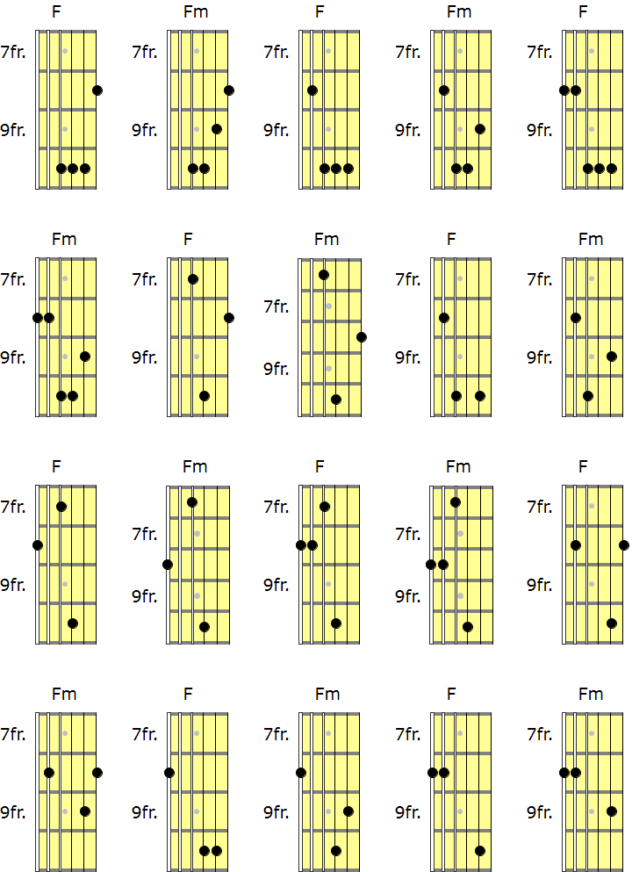

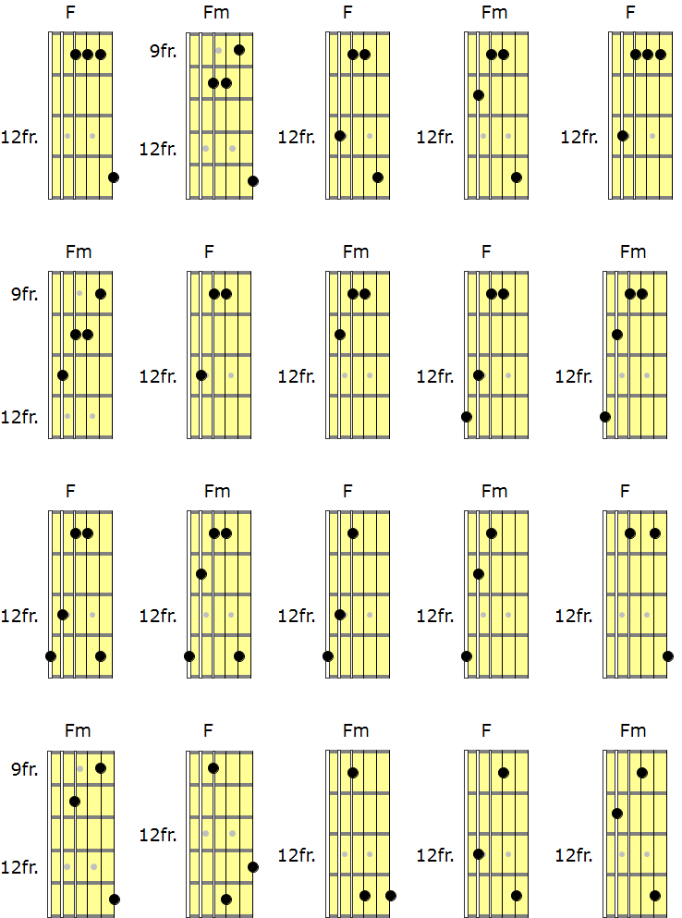

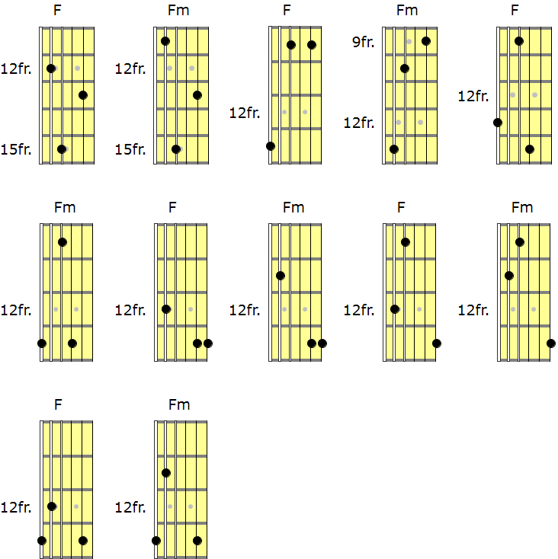
So many options with simple Major and Minor chords, it is easy to feel overwhelmed with the possibilities. Remember though, the thought process is simple – know the intervals. Be able to find the 1st, 3rd and 5th notes from the Major Scale and build major chords, all over the fretboard, any key. Be able to lower the 3rd to make Minor chords. Then, we can run our chord shape through a scale.
Here are some more examples of chord scales, using some of the F Major and F Minor chords shown so far;
F Major Triad ascending through the F Mixolydian Scale
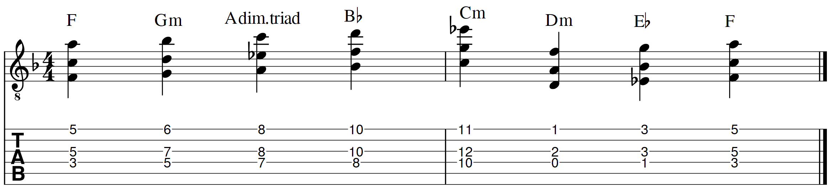
F Minor Triad ascending through the F Aeolian Scale (F Natural Minor)
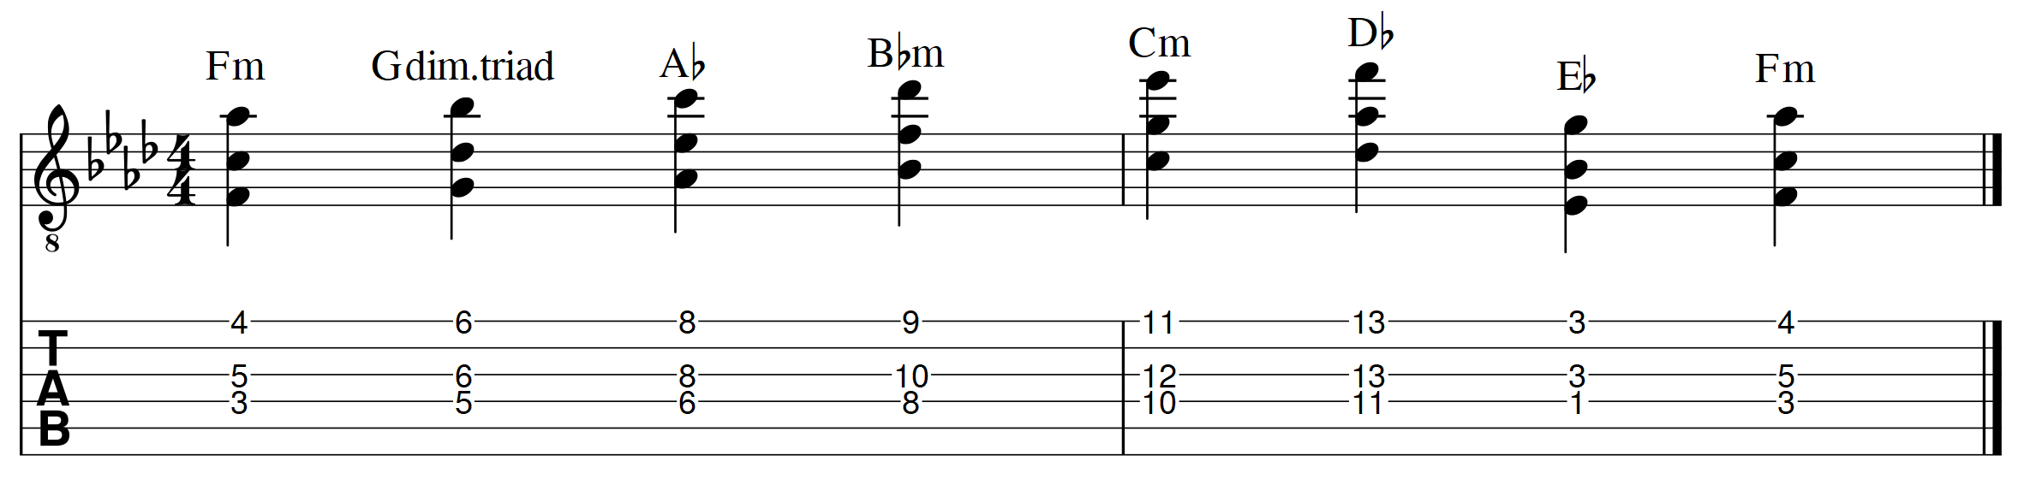F Major Triad descending through F Lydian
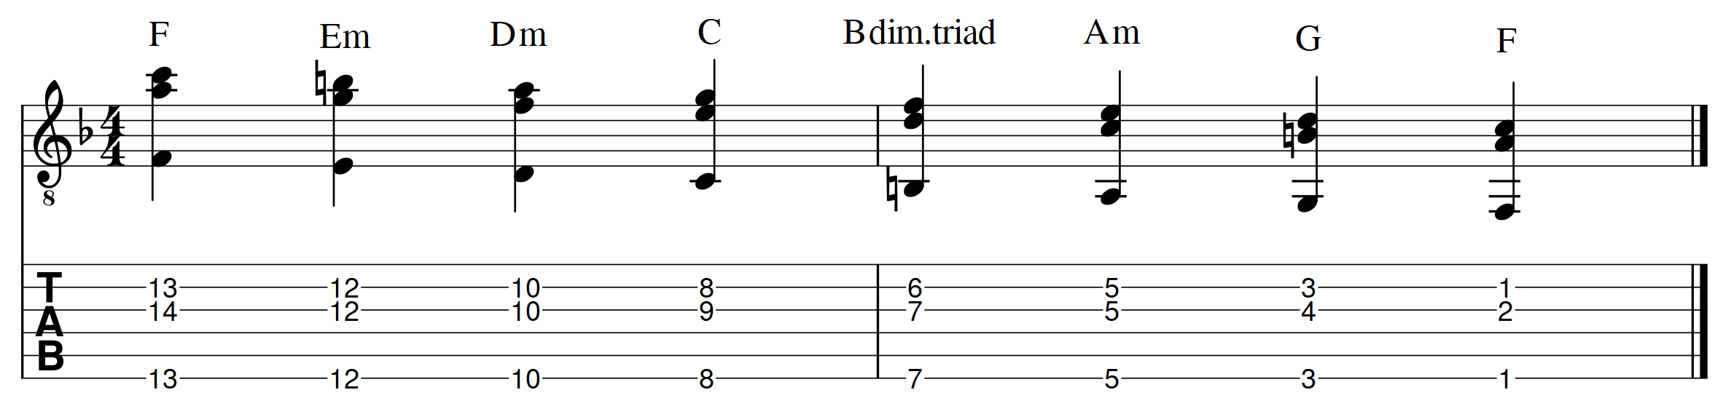F Minor Triad descending through F Phrygian
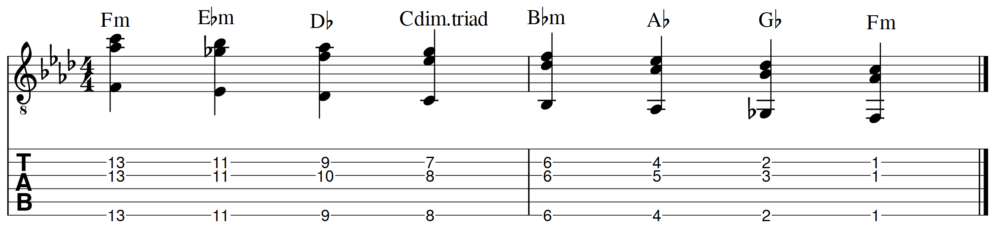
Experiment with and create your own chord scales. Any key, any Major Scale mode. Here are some more examples in different keys;
C Major Triad ascending through C Mixolydian
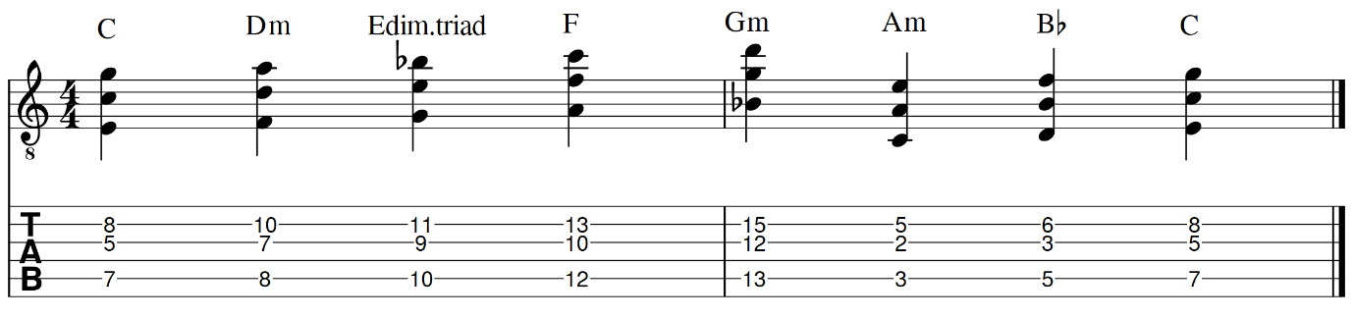
Bb Minor Triad ascending through Bb Dorian
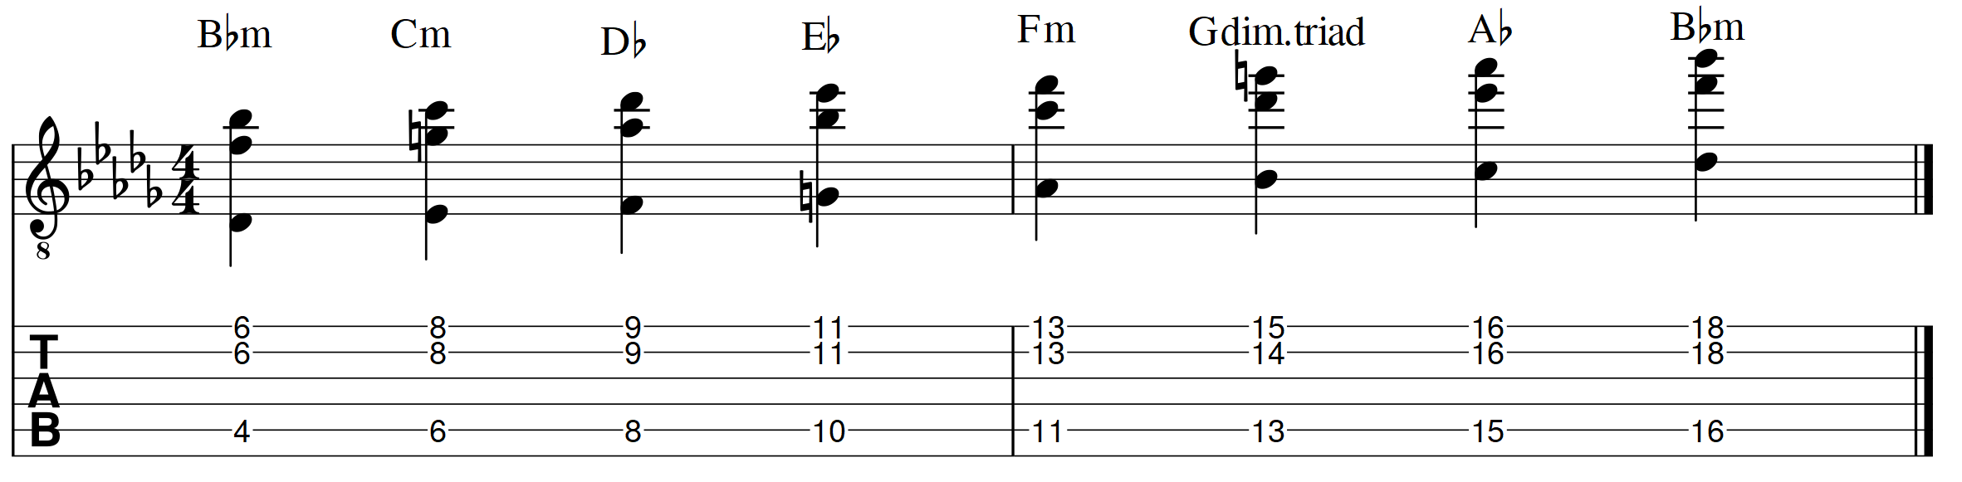
B Major Triad descending through B Ionian (B Major Scale)
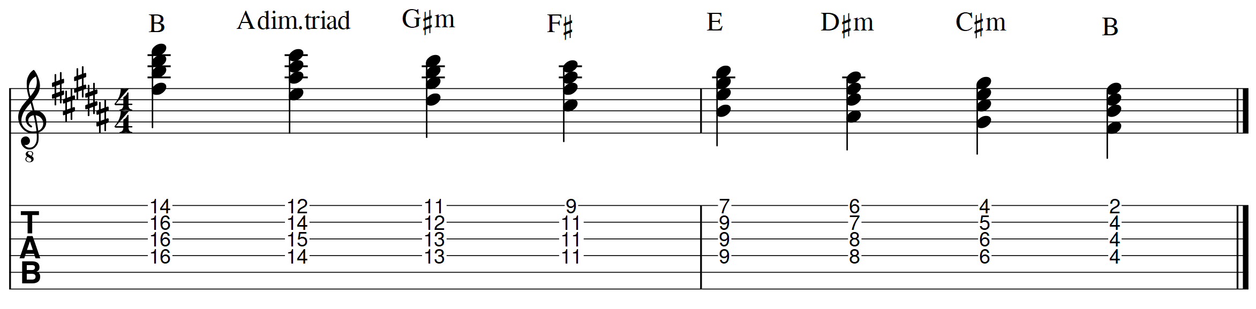
D Minor Triad ascending through D Phrygian
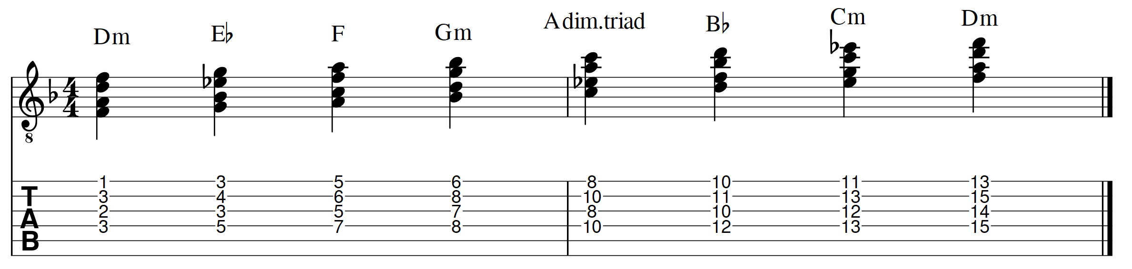
E Major Triad descending through E Ionian (E Major Scale)
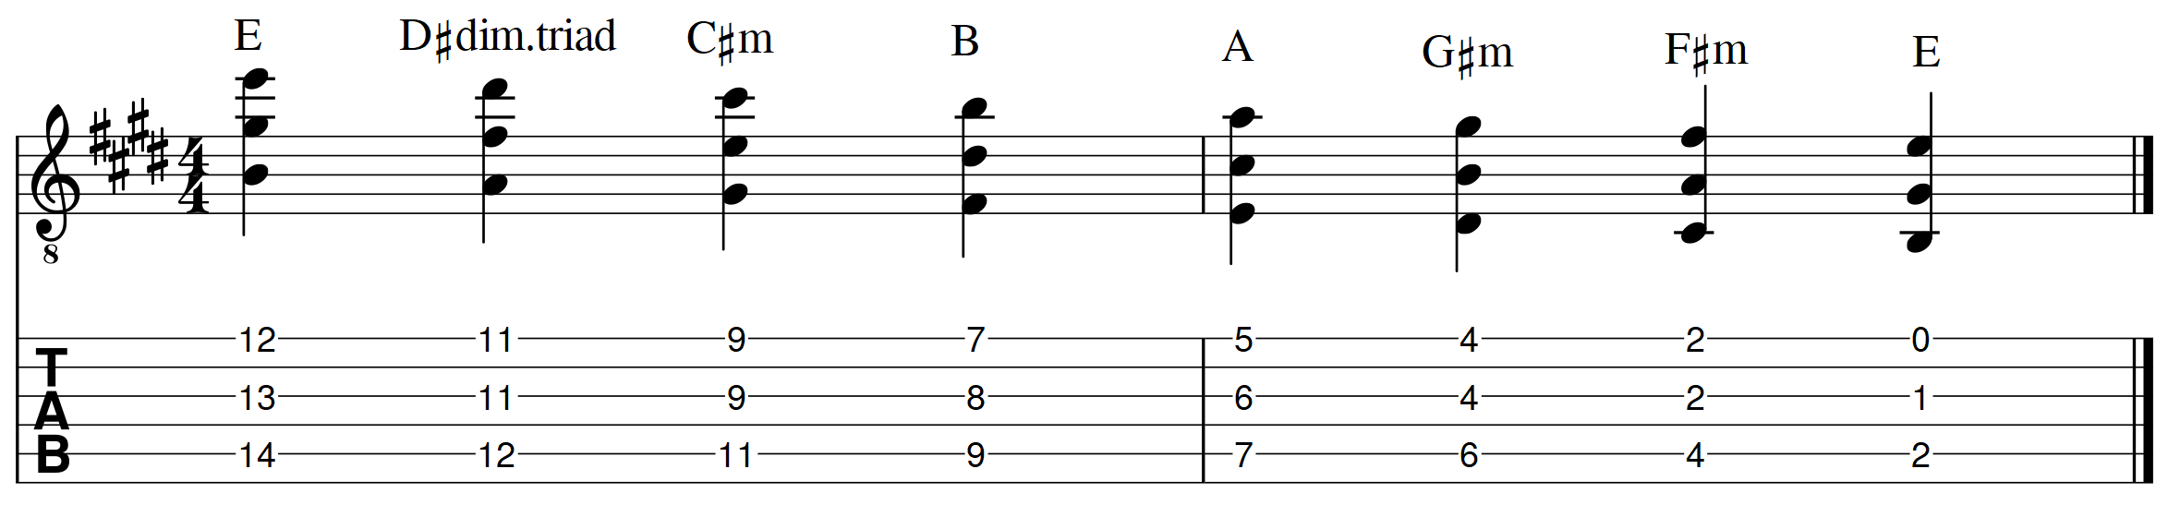
G Minor Triad descending through G Aeolian (G Natural Minor)
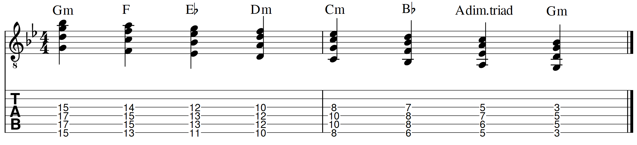
Db Major Triad ascending through Db Lydian
