APPENDIX TWO

Modes and Key Signatures

We know from Derivative thinking that every Major Scale mode shares the same notes as one of the Major Scales. For example, A Mixolydian has the same notes as the D Major Scale. E Phrygian has the same notes as the C Major Scale.

It would stand to reason then that scales with the same notes would share the same key signature. You would think that a song that uses the A Mixolydian Scale would share the same key signature as a song that uses the D Major Scale. You would think that a song that uses E Phrygian would have the same key signature as a song that uses the C Major Scale. However, on most occasions this is not the case.

When it comes to key signatures in Music, songs in a Major Tonality are written using the Major Scale notes of that particular key. So, a song in D Major that uses the D Mixolydian Mode (for example, “Sweet Home Alabama”, with the chords D, C and G) will have the key signature of the D Major Scale (F#, and C#). Any “C Natural” notes used in the song would be written using accidentals.

If we had a song in D Major that was constructed entirely using notes and chords from D Lydian (with the raised 4th, G#) it would still have the Key Signature of the D Major Scale. Any time a G# note appears, it would be written using accidentals.
E.g. Key Signature of a song that uses the D Major Scale, D Lydian or D Mixolydian;
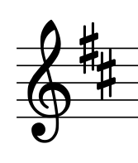
When it comes to minor keys, the default key signature is that of the Aeolian Mode (or Natural Minor Scale). For example, if we had a song in D Minor that was based entirely on notes and chords coming from the D Dorian Scale (i.e. no sharps or flats), the song would still use the D Natural Minor key signature (i.e. Bb). Any time a “B Natural” note is used in the piece it would be written using accidentals.
If we had a song based entirely around D Phrygian (which has a Bb and an Eb), the key signature would still be that of D Natural Minor (just the Bb). Any Eb’s used in the piece would be written using accidentals.
E.g. Key Signature of a song that uses D Natural Minor, D Dorian or D Phrygian;
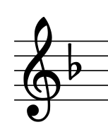
I have seen very occasional exceptions to these rules. I recall seeing a classical piece written using the G Phrygian Scale, and the composer chose to use a key signature of Bb, Eb, and Ab (rather than the usual Gm key signature of Bb & Eb). However, my experience has been that this is very rare, and the default key signatures are Major Scale (Ionian) for songs in a Major Tonality and the Natural Minor Scale (Aeolian) for songs in a Minor Tonality.

I think the key word here is Tonality. It simply means knowing whether a song/piece is in a Major or a Minor key. Key Signatures indicate tonality and key centre. They tell us quickly and succinctly whether a piece of music is in a Major or Minor key, and what key that is. However, they don’t tell us the exact notes within the key. They don’t distinguish between the different types of Major Tonality (e.g. Ionian, Mixolydian or Lydian). They don’t distinguish between different types of minor scales (e.g. Dorian, Phrygian, Aeolian, Locrian, Harmonic Minor or Melodic Minor).

Whilst this might seem strange, consider the alternative, where the exact notes of the mode are shown in the key signature. For example, imagine we saw this key signature at the start of a song;
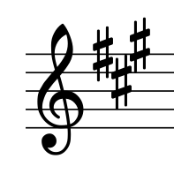
If the exact notes of a mode were to be shown in the key signature, it is possible that this key signature of 3 sharps could indicate A Ionian, B Dorian, C# Phrygian, D Lydian, E Mixolydian, F# Aeolian or G# Locrian. Isn’t it easier to be able to look at it and straight away know the piece of music is in A Major or F# Minor? Then, we can look further at the melody and chords used throughout the piece to determine if different types of A Major Tonality or F# Minor Tonality are being used. E.g. A Ionian, A Lydian, A Mixolydian, F# Aeolian, F# Dorian, or F# Phrygian.

By the way, if you don’t know your key signatures (in all keys) and the Circle of 5ths, go and learn them - they are essential when dealing with written music. There are heaps of books that cover this stuff, but a summary is shown on the next page. The Major keys are shown in upper case letters on the outside of the circle. The Minor keys are shown in lower case letters on the inside of the circle;
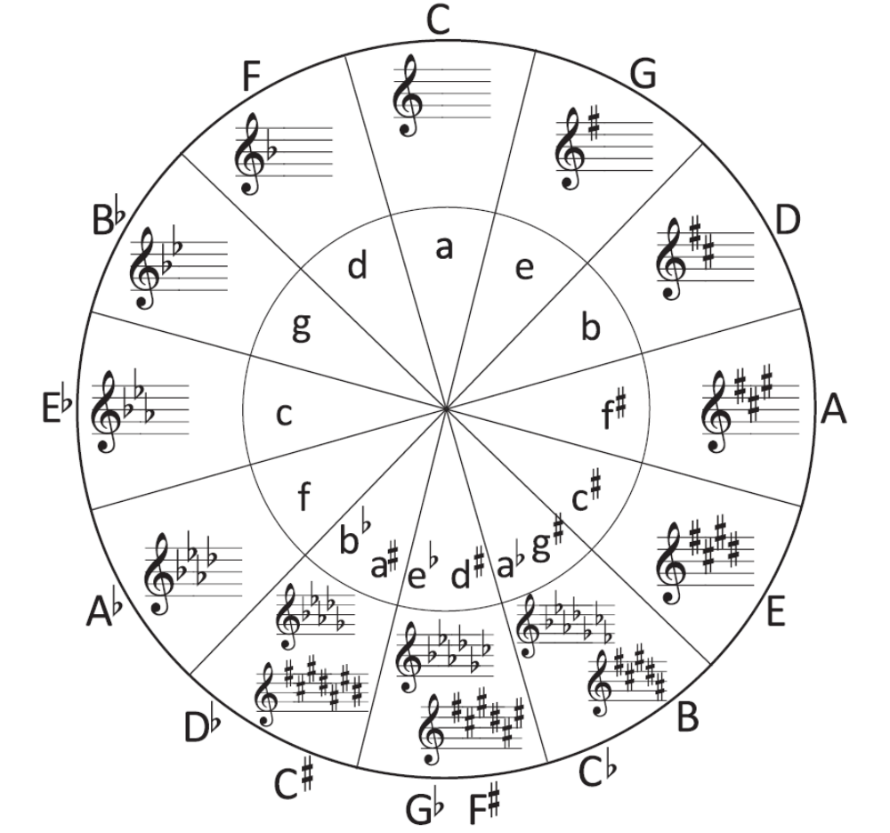

Key Signatures are essential and helpful, but they only provide limited information when it comes to the Major Scale Modes. Key Signatures are there to guide us with Major or Minor tonality, plus to tell us the key centre. They won’t tell us what mode is being used - to do this we will need to dig deeper and look at the melody and chords used throughout the piece.

Summary
- Songs in a Major Tonality (from the Major Scale Modes: Ionian, Mixolydian, Lydian), use the Major Scale Key Signature from the same key centre.
- Songs in a Minor Tonality (from the Major Scale Modes: Dorian, Phrygian, or Aeolian) use the Natural Minor Scale Key Signature from the same key centre.

