INTRODUCTION
This book is intended to help guitar students in using the Major Scale modes to play a wide range of music styles. Many Jazz students study the modes of the Major Scale as part of developing their improvising skills and chordal knowledge. For example, often beginning Jazz students will learn the Dorian Scale and related songs, such as “So What” or “Impressions”. However, the colours that come from the modes of the Major Scale can be helpful to all guitarists, regardless of their playing style. E.g. Rock, Blues, Soul, Funk, Country, Reggae, Metal, Latin, etc.
Another purpose of this book is to give contemporary guitar players wider scale and harmonic material to draw from, both in their soloing/improvising, their rhythm/chordal playing, their composing and their arranging. It has been my experience teaching guitar students that whilst many developing players are quite skilled at playing Pentatonic and Blues scales, the modes of the Major Scale remain a mystery to many, and scarce in their use. The Major Scale modes don’t have to belong in Jazz-land, they sound great in all kinds of styles!
Some background knowledge is assumed and encouraged prior to working through this book. Before getting into the Major Scale and its Modes I believe it is really important to have a solid grounding in the Minor Pentatonic Scale, The Major Pentatonic Scale, and the Blues Scale – all keys, all over the fretboard. There is so much great music to be found with these scales, particularly on the guitar.
Being able to play Major, Minor and 7th chords in any key is also assumed and encouraged. These are essential in being able to play contemporary music. Many guitarists learn these as part of their 6th string “E Shape” barre chords and their 5th string “A Shape” barre chords. If you don’t know this stuff already I think it would be wise to suss it out (there are many books that cover these things) before working through this book.
Consider the 2 common chord progressions shown below;
(1)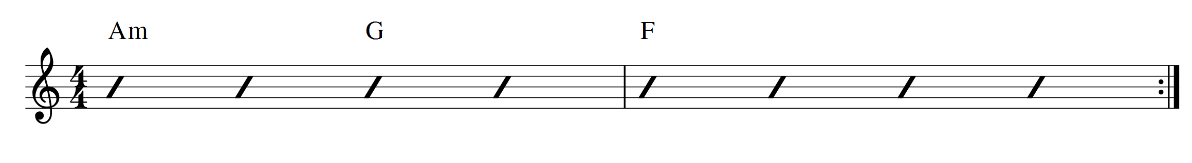
(2)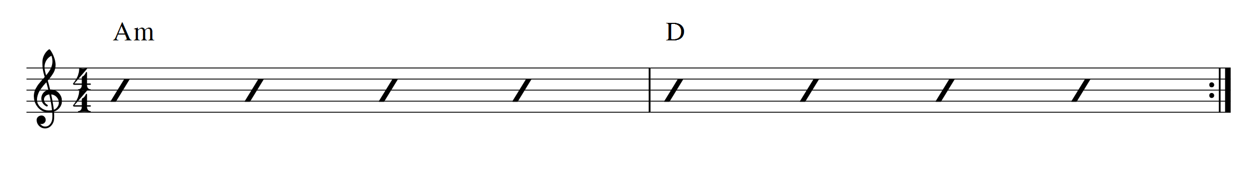
In improvising over both of these chord progressions many guitarists will head straight for the A Minor Pentatonic Scale. However, the first progression (with the use of the F Note) is also suggesting the A Aeolian Scale (or A Aeolian Mode, or A Natural Minor Scale). The second progression (with the F# in the D chord) is also suggesting the A Dorian Scale (or A Dorian Mode).
(Note: In the diagrams below the intervals in the scales are labelled; R, 2, b3, etc. If you don’t understand the intervals at this point, don’t worry, it will be explained later. The important thing here is to play the notes and hear the sounds.)
3 Positions of The A Aeolian Scale
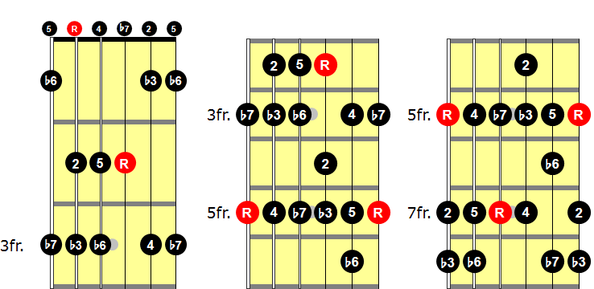
3 Positions of the A Dorian Scale
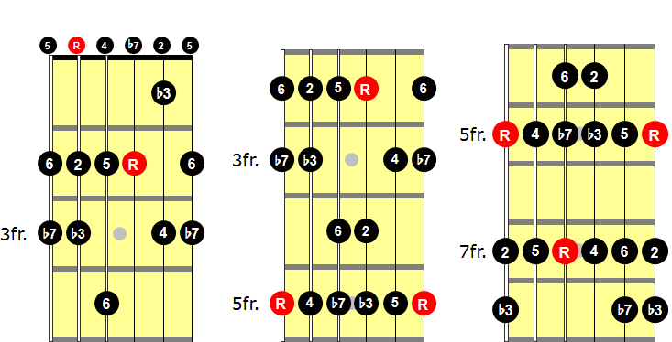

Try these scales out (A Aeolian for Prog. #1, A Dorian for Prog. #2). Record yourself playing the chord progressions and improvise over the top (get a loop pedal if you don’t have one already!). Notice that you are adding in a couple of extra notes that you don’t get in the Minor Pentatonic scale. These extra notes are very colourful – they give a different flavour, help to outline the chord progressions and will straight away help your playing to stand out from the “Pentatonic pack”.
I’m not suggesting for a moment to ditch the Pentatonic and Blues Scales. They work and many great players have shown time and again they can sound amazing! One of the reasons the Pentatonic Scales work so well is that they are a kind of “all purpose” scale – A Minor pent works over a range of “A Minor-Type” Chord Progressions, just as D Major Pentatonic scale will work over;
(i) 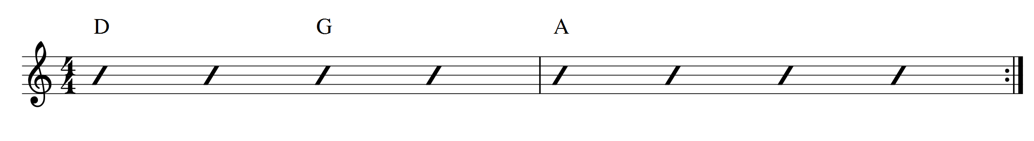Or, (ii)
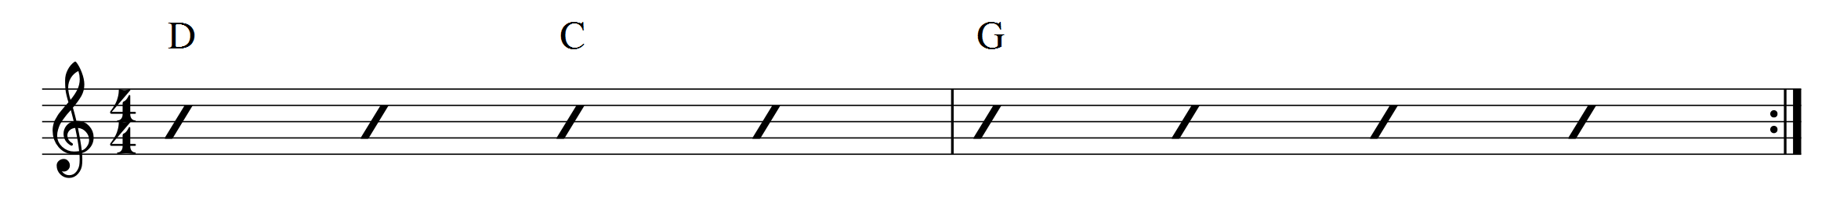
Or, (iii)
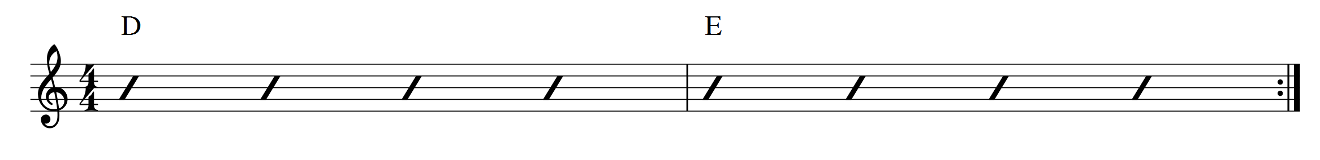
The pentatonic scales are, however, only part of the picture. In fact, what they really are is abbreviated modes – playing the Major Scale modes and leaving out some notes. Notice that the 3 progressions shown above are all in the key of D Major, but they are different in their character. Try playing the D Major Scale (D Ionian Mode) over (i), D Mixolydian over (ii), and D Lydian over (iii).

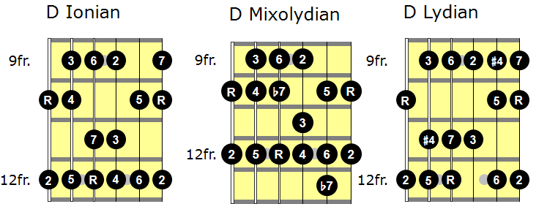
This book looks in depth at each of the 7 Major Scale Modes. We’re going to learn them all over the fretboard in all keys and learn to understand the chord progressions that fit with each mode. Within each mode and fingerboard position there are triads, 7th chords, scale-tone chords and pentatonic scales to learn. This study of scale/chord relationships can open up many new possibilities when it comes to voicing chords, improvising, arranging and composing.
In Section Three there are 100 recorded musical examples of single note lines and chords that use the Major Scale Modes. Many of these examples use the concept of super-imposing triads, 7th chords and pentatonic scales over a single chord. E.g. If we know we can play D Dorian over a static Dm chord then we can also play anything that comes from the D Dorian Scale over the chord. E.g. The triads Dm, Em, Am, C Maj, F Maj, and G Maj; the 7th chords Dm7, Em7, Am7, C Maj7, F Maj7, or G7; also the Pentatonic Scales Dm Pent, Em Pent, Am Pent, C Maj Pent, F Maj Pent, and G Maj Pent.
In his excellent book “The Advancing Guitarist”, Mick Goodrick writes that when we improvise over one chord it is a bit like “making a curve go through a straight line”. When we improvise over a progression of chords it is a bit like “making a straight line go through a curve”. In this respect many of the examples in Section Three could be said to be in the category of trying to “make a curve go through a straight line” – triads, 7th chords and pentatonic scales being super-imposed over a single static chord. However, for each Mode there are also example chord progressions given, where the student can learn familiar modal chord progressions and applications.
The important concept of parallel thinking vs derivative thinking is explored. More on this to follow, but parallel thinking means thinking of, say, a G Dorian scale as a type of “G” scale, with “G” as the key centre. Derivative thinking would think of G Dorian as an F Major Scale, playing from the 2nd note of the scale. The pros and cons of each method will be examined. In fact, I believe it’s not so much parallel vs derivative as parallel and derivative – both approaches can unlock new possibilities.
Another intention of this book is that by hopefully opening the students’ ears to these new colours, more colours and exploration will follow. E.g. The Modes of the Melodic Minor Scale, the Harmonic Minor Scale and its Modes, Diminished Scales, Bebop scales, etc. These in turn can lead to playing bop, swing, latin, fusion, wherever you want to go! It is my hope that this book will help you to progress down the infinite and immensely enjoyable road of harmony, chord/scale relationships, and most importantly, creating music that moves the soul.

Geoff Haymes

