LESSON NINE
Roman Numerals are used in Music to indicate chords. I = the chord from the 1st note of the scale, ii = the chord from the 2nd note of the scale, etc.

Generally a Roman Numeral by itself will indicate a triad, whilst 7ths and other chords are written after the Roman Numeral. For instance, if we are in the key of C Major, a C Major chord would be written as I, whilst a C Maj7 would be written as I Maj7. An Am would be indicated by vi or vim, an Am7 would be written as vim7. Capital Roman Numerals indicate Major chords, whilst lower case Roman Numerals are used to represent Minor chords.

Remember from Lesson Two;
Chords from the C Major Scale – Basic Triads
Chord from 1st note of scale = CEG = C Major Triad
Chord from 2nd note of scale = DFA = D Minor Triad
Chord from 3rd note of scale = EGB = E Minor Triad
Chord from 4th note of scale = FAC = F Major Triad
Chord from 5th note of scale = GBD = G Major Triad
Chord from 6th note of scale = ACE = A Minor Triad
Chord from 7th note of scale = BDF = B Diminished Triad

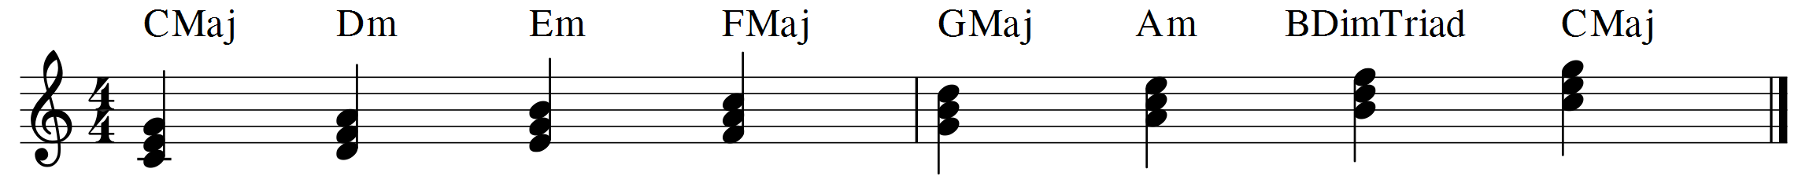
I ii iii IV V vi vii I
Notice the Roman Numeral pattern for the Major Scale. This is true for all Major Scales;
I, IV & V = Major Triads
ii, iii & vi = Minor Triads
vii = Diminished Triad
Thinking of chord progressions in Roman Numerals is very helpful. It enables us to recognise common chord patterns and learn songs quickly. It enables us to be able to easily change keys of songs. It helps us to recognise the scale a song is using, and in turn make appropriate choices for soloing, improvising or arranging.

The table below shows the triads in all 12 Major Scales;

Major Key | I Chord | ii Chord | iii Chord | IV Chord | V Chord | vi Chord | vii Chord
C Major | C | Dm | Em | F | G | Am | B Dim. Triad
G Major | G | Am | Bm | C | D | Em | F# Dim. Triad
D Major | D | Em | F#m | G | A | Bm | C# Dim. Triad
A Major | A | Bm | C#m | D | E | F#m | G# Dim. Triad
E Major | E | F#m | G#m | A | B | C#m | D# Dim. Triad
B Major | B | C#m | D#m | E | F# | G#m | A# Dim. Triad
F Major | F | Gm | Am | Bb | C | Dm | E Dim. Triad
Bb Major | Bb | Cm | Dm | Eb | F | Gm | A Dim. Triad
Eb Major | Eb | Fm | Gm | Ab | Bb | Cm | D Dim. Triad
Ab Major | Ab | Bbm | Cm | Db | Eb | Fm | G Dim. Triad
Db Major | Db | Ebm | Fm | Gb | Ab | Bbm | C Dim. Triad
Gb Major | Gb | Abm | Bbm | Cb | Db | Ebm | F Dim. Triad

The same thing can be done with 7th chords. Remember from Lesson Seven;
Chords from the C Major Scale – 7ths
C Maj7 = C E G B
Dm7 = D F A C
Em7 = E G B D
F Maj7 = F A C E
G7 = G B D F
Am7 = A C E G
Bm7b5 (Also known as B Half Diminished) = B D F A

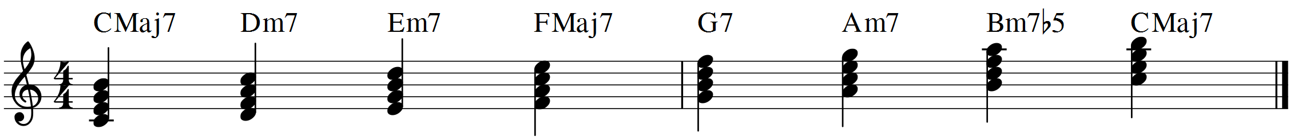
IMaj7 iim7 iiim7 IVMaj7 V7 vim7 viim7b5 IMaj7

Again, this Roman Numeral pattern remains the same for 7th chords in all Major keys;

I & IV = Maj7
ii, iii, vi = m7
V = 7th (also known as Dominant 7th)
vii = m7b5

The table over the page shows the 7th chords in all 12 Major scales.

Major Key | I Chord | ii Chord | iii Chord | IV Chord | V Chord | vi Chord | vii Chord
C Major | C Maj7 | Dm7 | Em7 | F Maj7 | G7 | Am7 | Bm7b5
G Major | G Maj7 | Am7 | Bm7 | C Maj7 | D7 | Em7 | F#m7b5
D Major | D Maj7 | Em7 | F#m7 | G Maj7 | A7 | Bm7 | C#m7b5
A Major | A Maj7 | Bm7 | C#m7 | D Maj7 | E7 | F#m7 | G#m7b5
E Major | E Maj7 | F#m7 | G#m7 | A Maj7 | B7 | C#m7 | D#m7b5
B Major | B Maj7 | C#m7 | D#m7 | E Maj7 | F#7 | G#m7 | A#m7b5
F Major | F Maj7 | Gm7 | Am7 | Bb Maj7 | C7 | Dm7 | Em7b5
Bb Major | Bb Maj7 | Cm7 | Dm7 | Eb Maj7 | F7 | Gm7 | Am7b5
Eb Major | Eb Maj7 | Fm7 | Gm7 | Ab Maj7 | Bb7 | Cm7 | Dm7b5
Ab Major | Ab Maj7 | Bbm7 | Cm7 | Db Maj7 | Eb7 | Fm7 | Gm7b5
Db Major | Db Maj7 | Ebm7 | Fm7 | Gb Maj7 | Ab7 | Bbm7 | Cm7b5
Gb Major | Gb Maj7 | Abm7 | Bbm7 | Cb Maj7 | Db7 | Ebm7 | Fm7b5

The following chord progressions are written in Roman Numerals and are used in many songs. Be able to play them in all 12 keys. Use the “C Shape” patterns and chords we have covered so far in this book, but you might also like to try any other shapes you know (e.g. “E Shapes”, “A Shapes”, “D Shapes”, etc. ). There are 5 Major scale shapes that cover the whole fretboard, known as “C A G E D”. More on this to come.

(10)
Play the chord progressions using the triads in each Major Scale, but also play them using the 7th chords from a key. E.g. (8) in Bb Major using 7th chords would become;

