LESSON THIRTY EIGHT

G PHRYGIAN SCALE (OR MODE)

Parallel Thinking

Looking at the table in Lesson 28, the next Major Scale Mode is the Phrygian Mode.
Major Scale = 1 2 3 4 5 6 7 8  Mixolydian = 1 2 3 4 5 6 b7 8  Dorian = 1 2 b3 4 5 6 b7 8  Aeolian = 1 2 b3 4 5 b6 b7 8  Phrygian = 1 b2 b3 4 5 b6 b7 8 | In the Key of “G”  G Major Scale = G A B C D E F# G  G Mixolydian = G A B C D E F G  G Dorian = G A Bb C D E F G  G Aeolian = G A Bb C D Eb F G  G Phrygian = G Ab Bb C D Eb F G

As discussed in previous lessons, Parallel Thinking enables us to hear the Phrygian Scale as a scale in itself, not as a derivative of another Major Scale. We want to hear the note “G” as the Key Centre or “1” of G Phrygian, not as the 3rd note of the Eb Major Scale. You can see from above that G Phrygian is a G Major Scale with a lowered 7th, a lowered 3rd, a lowered 6th and a lowered 2nd. Again, notice that the modes get progressively darker as one note changes each time.

The lowered 2nd (combined with the lowered 3rd and lowered 6th) gives the Phrygian a darker minor sound than the Aeolian. The b2 gives a Spanish kind of quality to the sound. It is used in Jazz and Classical Music, such as the melody to “La Fiesta” by Chick Corea, or parts of the melody to “Bolero” by Maurice Ravel. However, the scale is also used in a range of contemporary styles such as Rock, Blues and Metal – players as varied as Stevie Ray Vaughan to the blokes from Metallica!

Derivative Thinking

Using Derivative thinking, we know that the Phrygian Scale is like playing from “3” to “3” of the Major Scale. Therefore, G Phrygian will have the same notes as the Eb Major Scale. If it has the same notes, it will also have the same triads, 7th chords and Pentatonic Scales.

G Phrygian Triads: Gm, Ab Maj, Bb Maj, Cm, D Dim. Triad, Eb Maj, Fm
G Phrygian 7th Chords: Gm7, Ab Maj7, Bb7, Cm7, Dm7b5, Eb Maj7, Fm7.
G Phrygian Pentatonic Scales: Gm, Ab Maj, Bb Maj, Cm, Eb Maj, Fm.

Written below are the 5 “CAGED” shapes for the G Phrygian Scale, enabling us to play the scale over the whole fretboard. Also shown are the G Minor arpeggios and the Gm7 arpeggios for each “CAGED” position. Be able to also play the G Phrygian triads, 7th chords and pentatonic scales listed in the box on the previous page, in every “CAGED” position.

G Phrygian Shapes

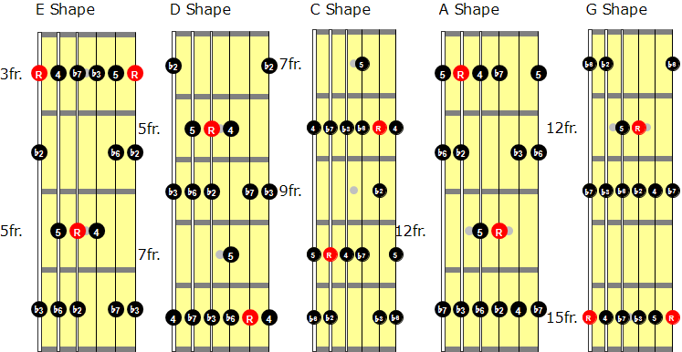

G Minor Arpeggios

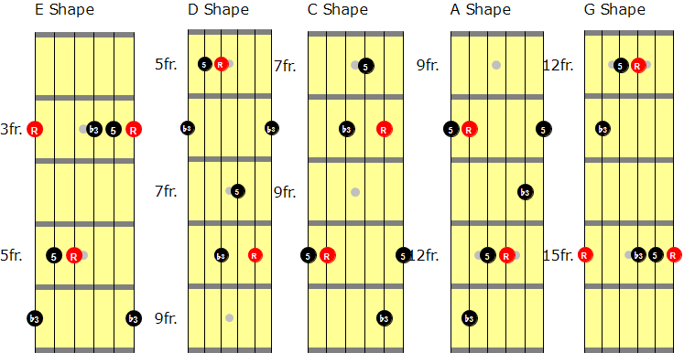

G Minor 7th Arpeggios

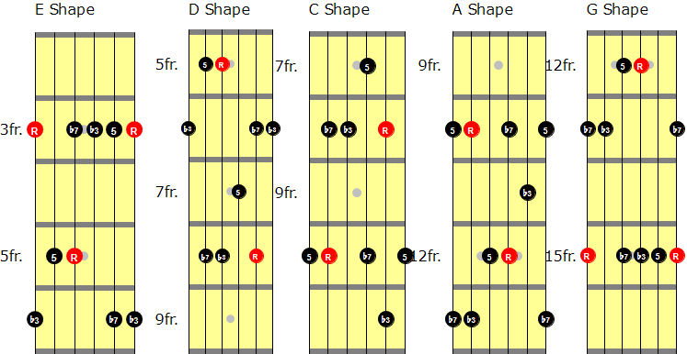

G PHRYGIAN EXAMPLES

- 83. A Spanish-sounding G Phrygian lick using hammer-ons and pull-offs;
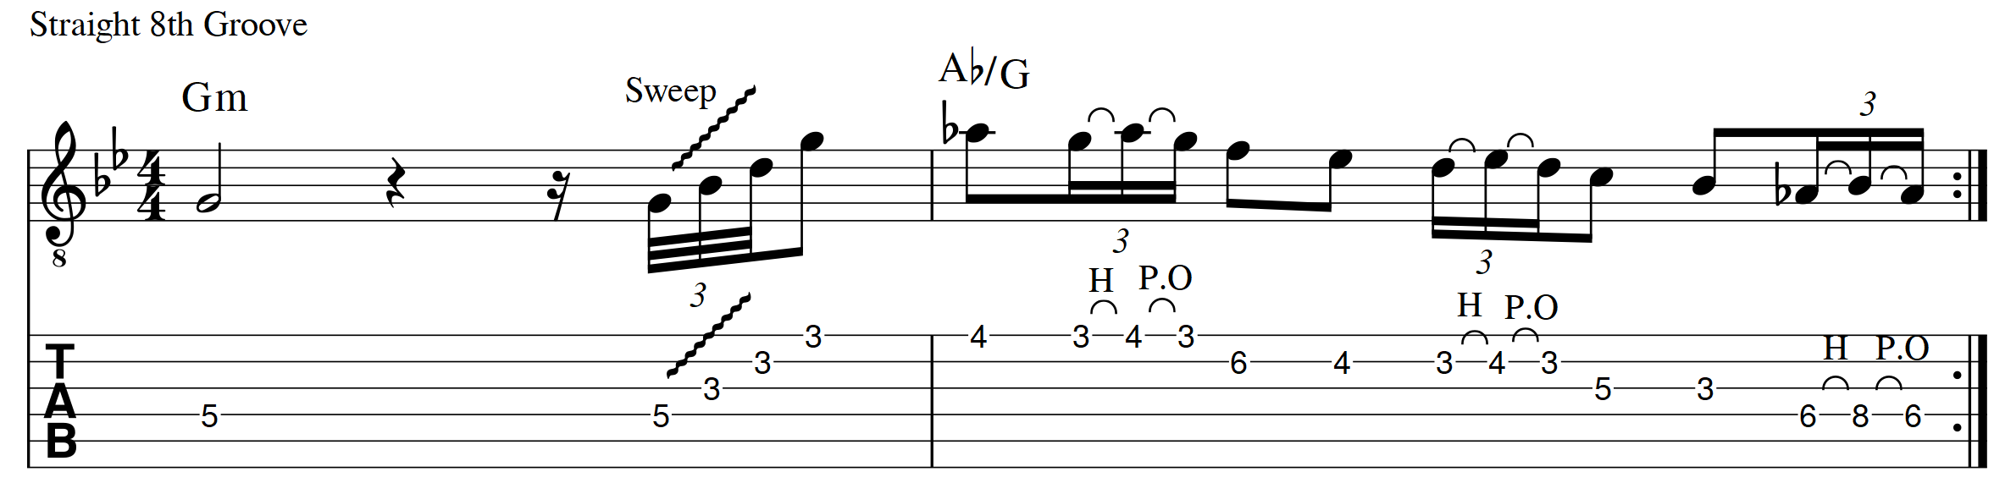

- 84. We can always create a Phrygian sound by playing a Major Triad or a Major 7th chord up a semitone from our Key Centre. This line is built around an AbMaj7 arpeggio, played over the Gm tonality;
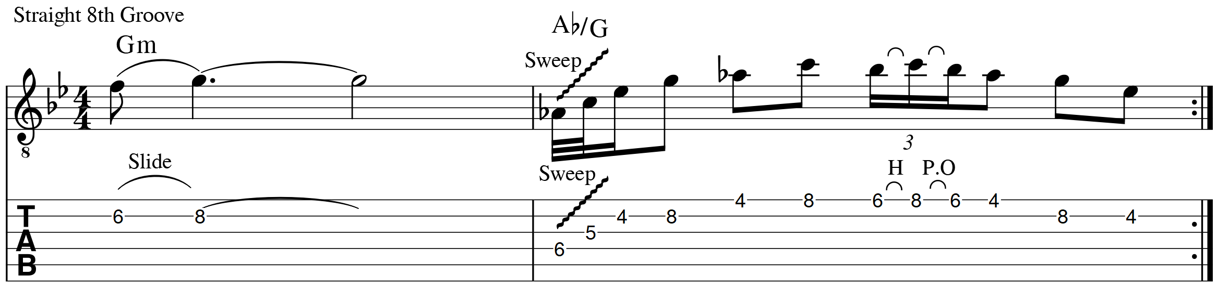

- 85. This line combines the G Blues Scale with G Phrygian. The descending Ab Major Triad (on beat 4) really emphasizes the Phrygian sound;

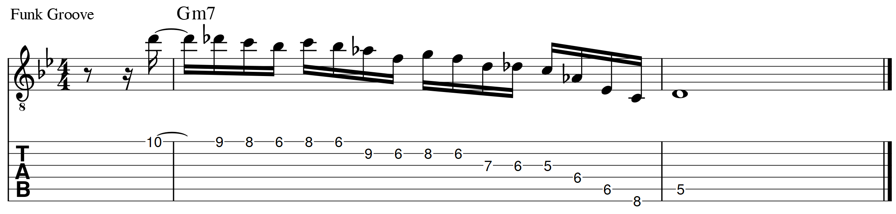

- 86. This one combines an Eb Maj7 arpeggio with an Ab Add9 arpeggio, all played over a Gm7 chord;
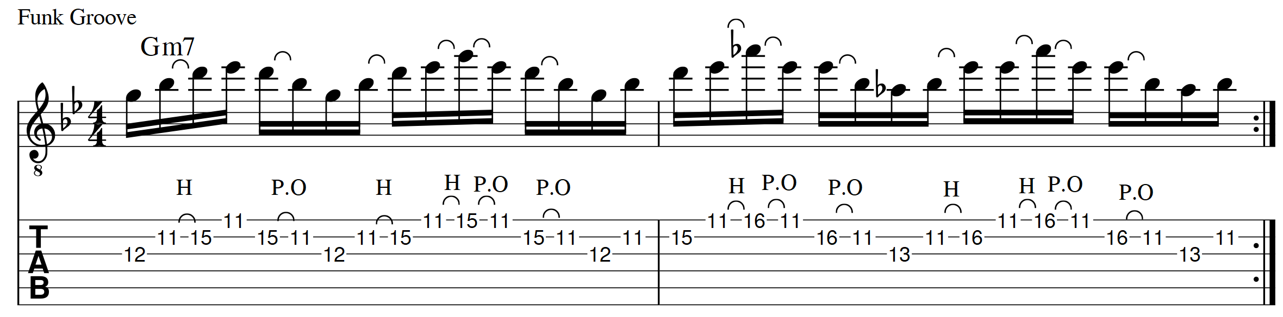

- 87. This line uses octaves and ascends through an Ab Major 9th arpeggio, all played over a Gm7 chord;
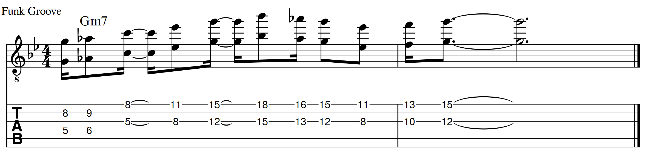

- 88. Another quick way of generating a Phrygian sound is to play a Minor Pentatonic Scale down a tone from the Key Centre. This line combines Gm and Fm Pentatonic Scales over a static Gm7 chord;

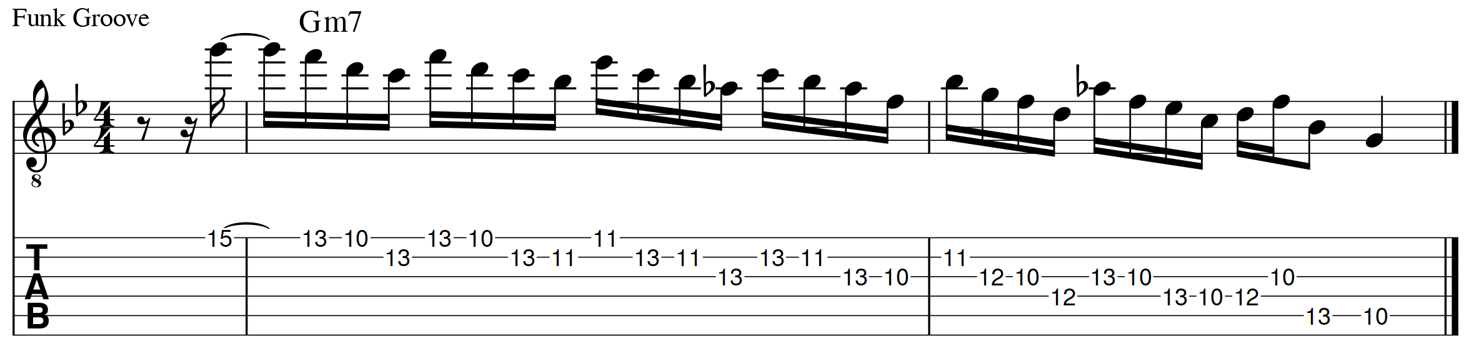

Often in Phrygian chord progressions, to give a different (and some would say stronger) sound, the I (or Tonic) Chord is changed from a Minor chord to a Major chord. For example, consider the classic cliché “bullfight” chord progression;

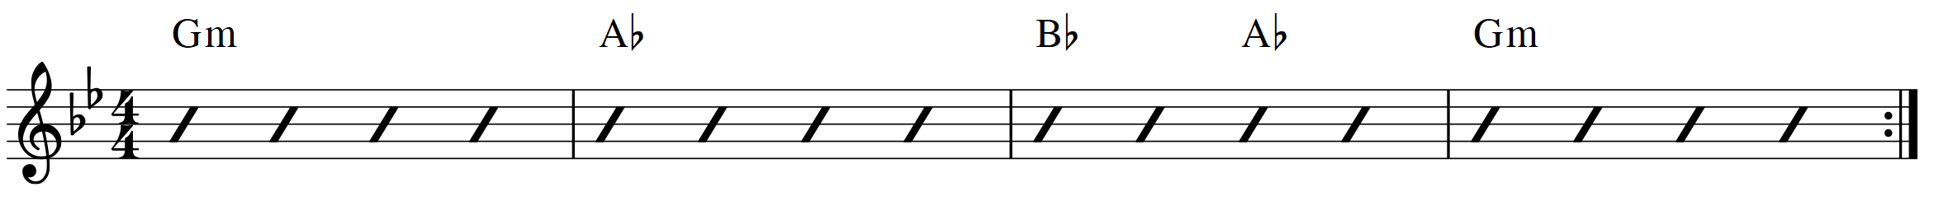

The Gm can be changed to a G Major chord;

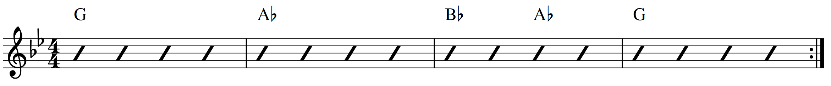

Notice that just one note has changed from G Phrygian – the Bb in the G Minor chord has been changed to a B Natural, creating the G Major Chord. Therefore, we can do the same when we are soloing over the G Major chord –change the Bb in the G Phrygian scale to a B Natural. The new scale is shown below;

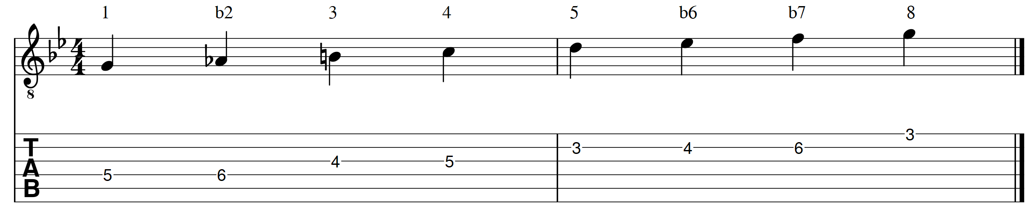

This scale is known as the Phrygian Dominant Scale, or the Spanish Phrygian Scale. It has an exotic kind of sound and it has been used in a wide variety of music styles from around the world, including Flamenco, Indian, Asian, Middle Eastern, Eastern European, Arabic and Jewish (e.g. “Hava Nagila”).

You may have noticed that the G Phrygian Dominant Scale has the same notes as the C Harmonic Minor Scale. In keeping with the ideas discussed in this book, thinking of the scale as a kind of “G” scale is Parallel Thinking. Thinking of the scale as playing “5” to “5” of C Harmonic Minor is an example of Derivative Thinking. Both ways of thinking can be useful, but as mentioned throughout this book I believe it is very important we utilise parallel thinking and know the scale as a “G” kind of scale;

G Phrygian Dominant Scale = 1 b2 3 4 5 b6 b7 8
(or Spanish Phrygian Scale)

These last two examples combine the G Phrygian Scale with the G Phrygian Dominant Scale;

- 89. Notice that G Phrygian Dominant is played here over the G Major Chord, G Phrygian is played over the Ab Major Chord;

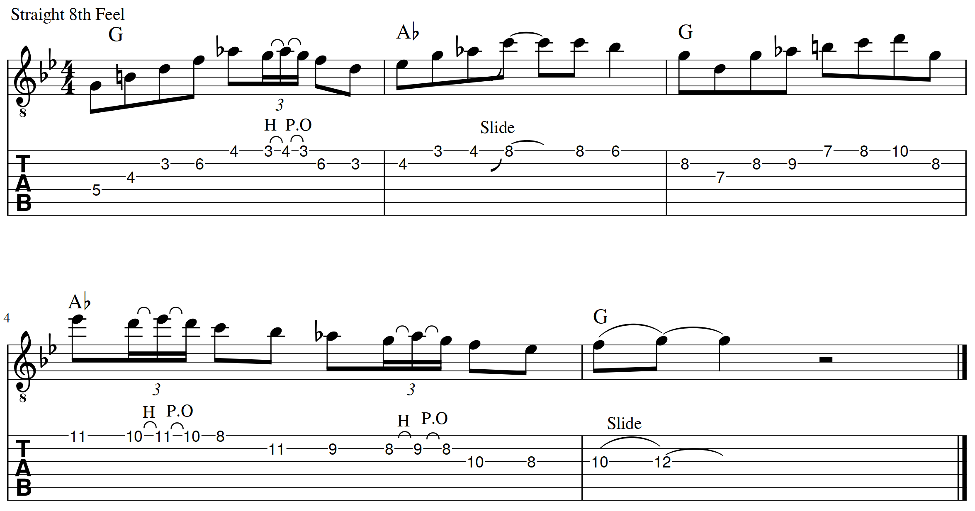

- 90. Again, using a B Natural note to fit with the G Major Chord;

