LESSON THIRTY ONE

Before we move on to the other Major Scale Modes, here are some Jazz-flavoured G Major Scale I, vi, ii, V chord voicings. Jazz players would most likely add tension, alterations and substitutions to these chords, creating a wider range of moods. The examples below sound comparatively cheerful and very consonant – in keeping with where we are at in this book I have deliberately stayed within the G Major Scale. Nevertheless, if you haven’t learnt these chords before they can be useful and treated as a kind of chord dictionary. Note that some chords will need to be played either with the fingers or with pick and fingers.

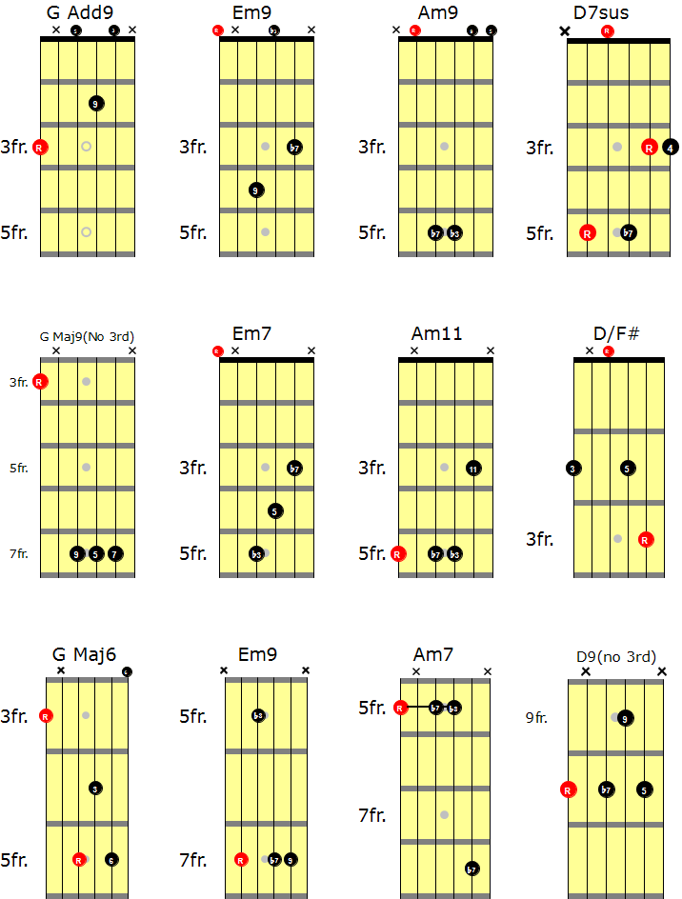
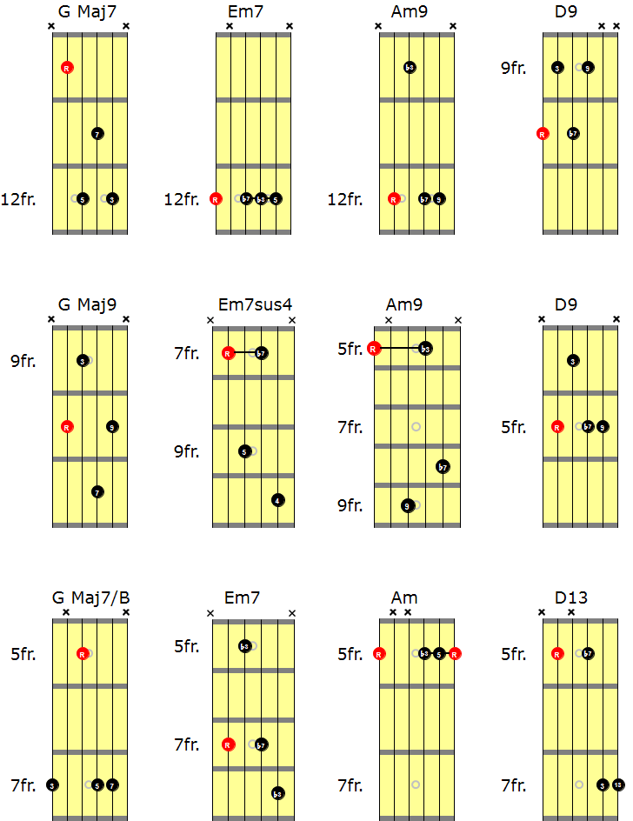

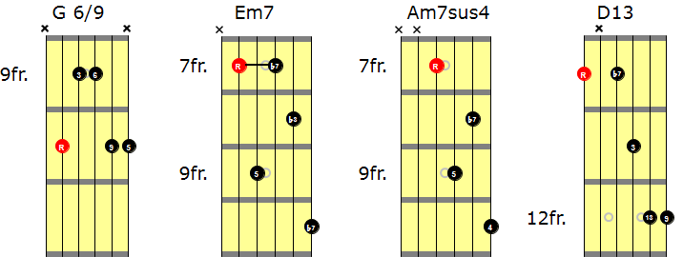

Written below are 8 common G Major Scale chord progressions, using basic triads. Loop/record yourself playing the chords, then compose/improvise melodic lines over the top using the “C.A.G.E.D” shapes shown in the previous lesson.

